10. Extinction
HERE LIES THE ENTRY FOR AN IMAGINED THING
This is a thing imagined by Jimmy, aged 10, on Wednesday April 21
The full name of this thing is: extinction
It can be found in: the past on earth
It is known that: it is about dinosaurs getting extinct and a volcano erupting
This thing has three important features: volcano, asteroid, and dinosaurs

An image of extinction can be found here:
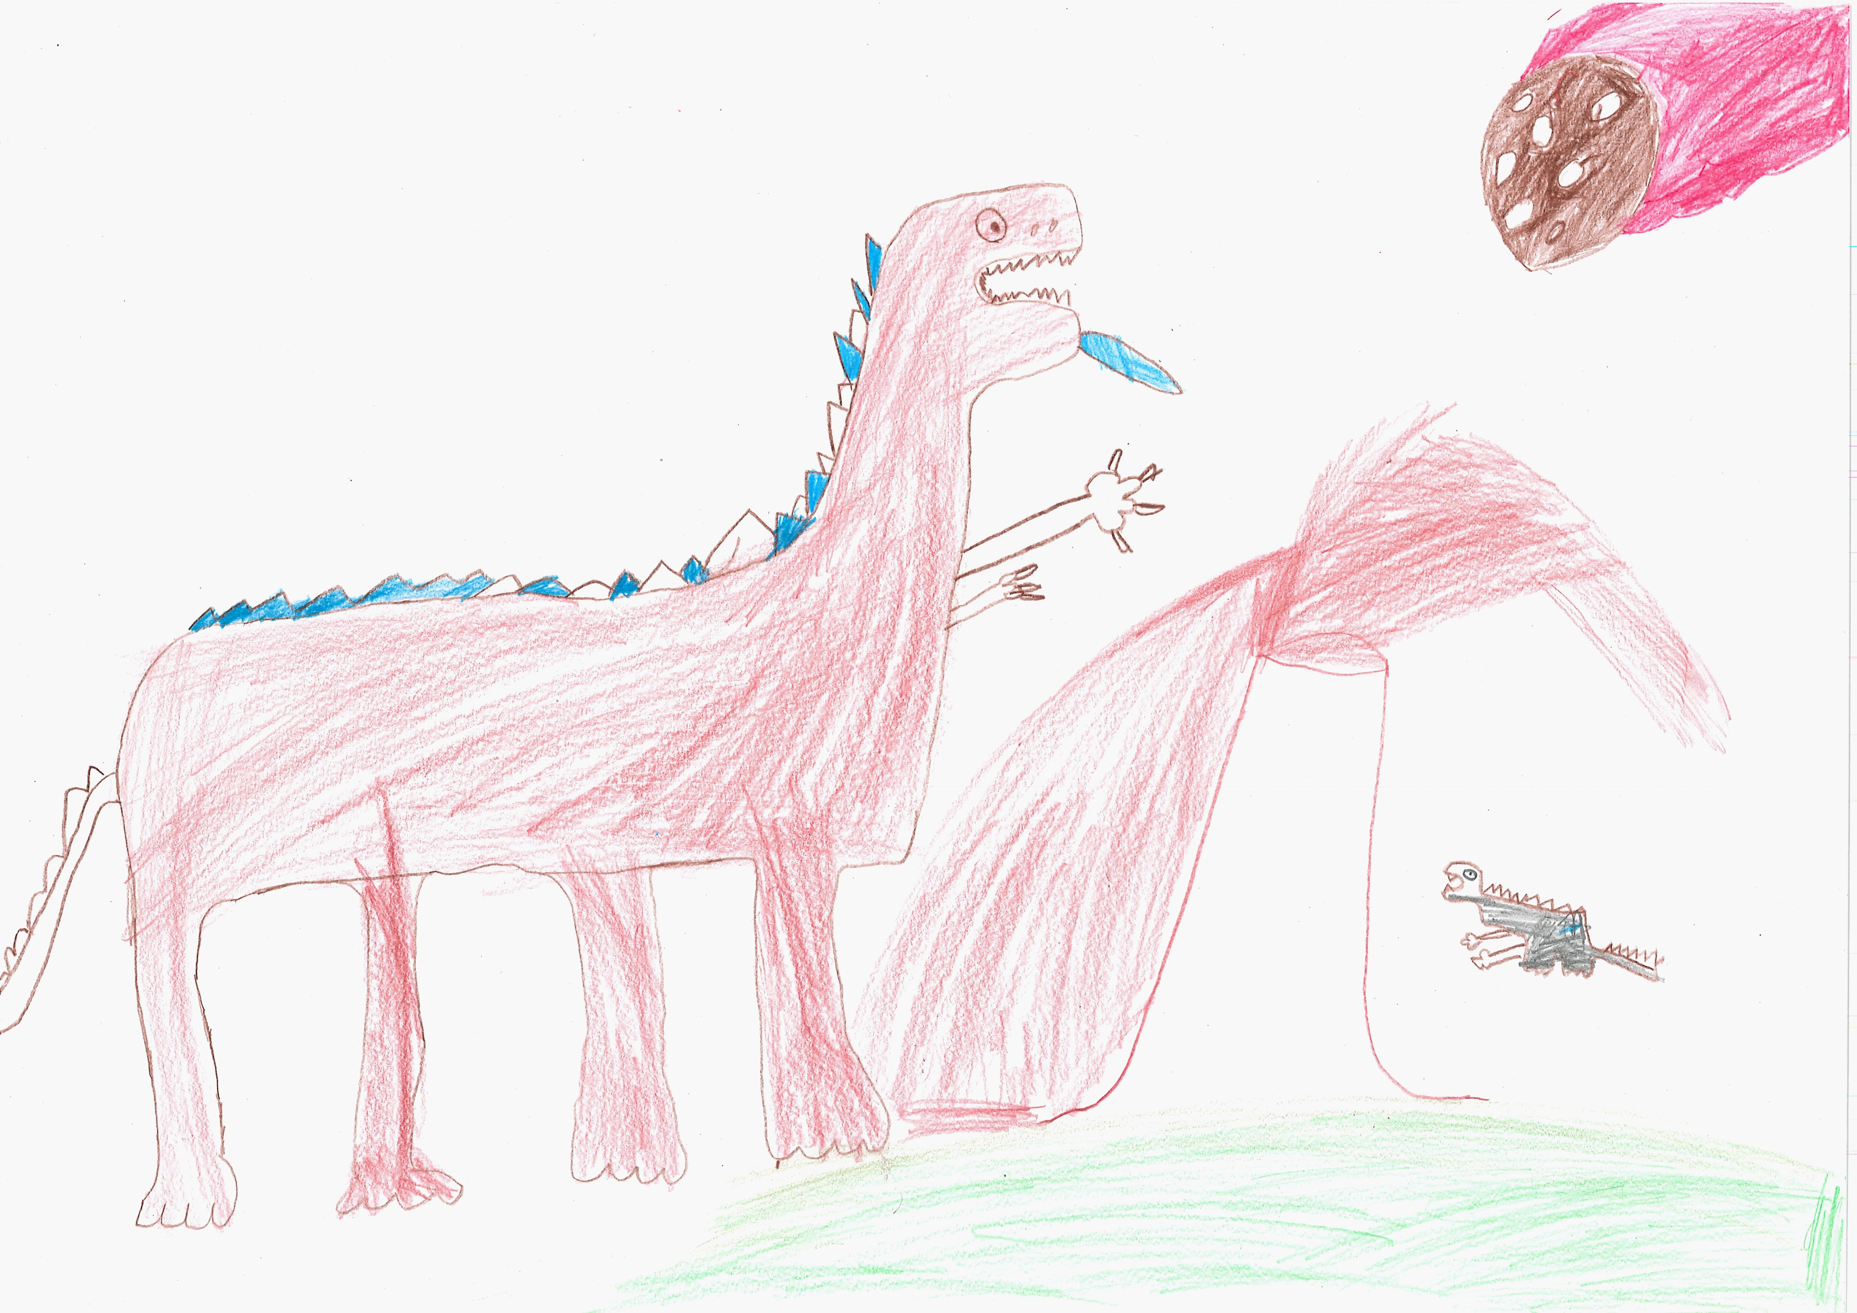400

A recording extinction can be found here:
400

This is the unique QR code for this Imagined Thing. Right click it to save then share it, so you and others can find your way back to here to this point of The Well.

IT IS KNOWN! HUZZAH FOR THE GREAT & GRAND RUMPUS!

