0. The Mermaid Kingdom
HERE LIES THE ENTRY FOR AN IMAGINED THING
This is a thing imagined by Ella, aged 10, on Wednesday April 21
The full name of this thing is: the mermaid kingdom
It can be found in: the sea in my amagination
It is known that: one day in the mermaid kingdom ther was a thif coming to steal 2 things. the thing that hod it up and the legendary gem but of corce he got cort by the princess ella the end. by ella.
This thing has three important features: mermaids, the casel, and the King and queen

An image of the mermaid kingdom can be found here:
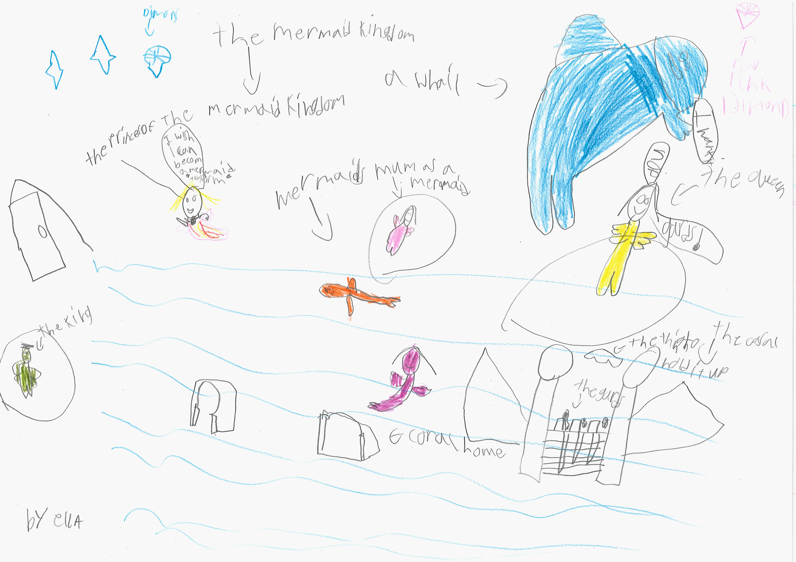400
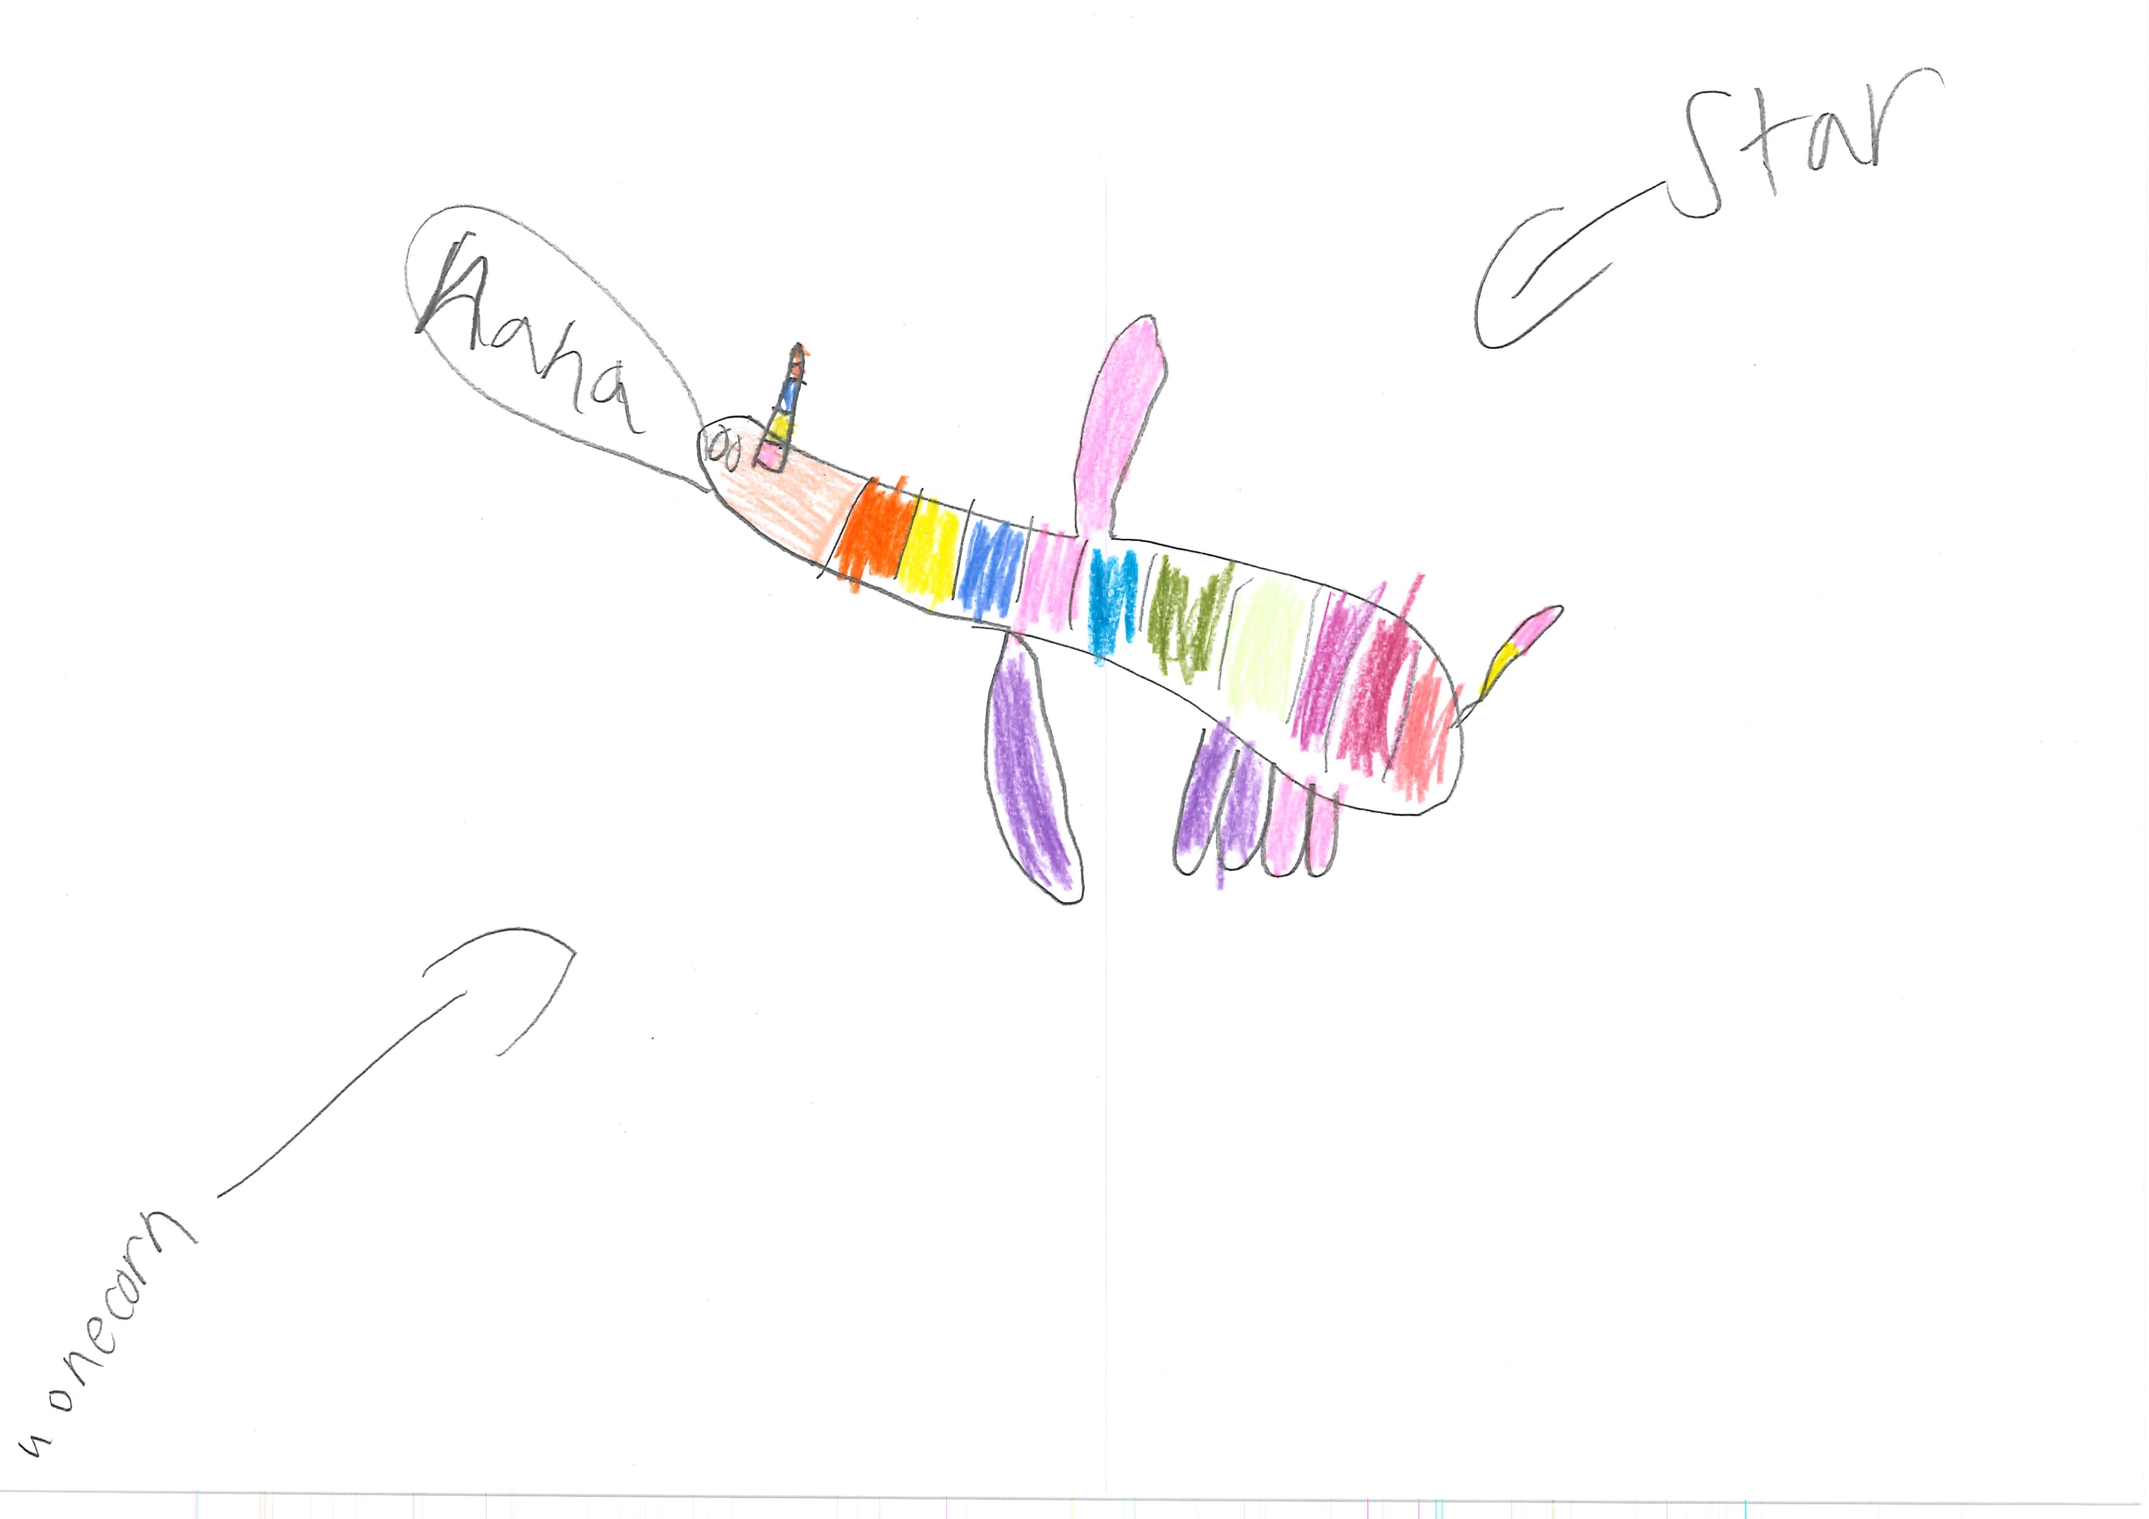400

This is the unique QR code for this Imagined Thing. Right click it to save then share it, so you and others can find your way back to here to this point of The Well.

IT IS KNOWN! HUZZAH FOR THE GREAT & GRAND RUMPUS!

