Grumpus Filters

Grumpus Augmented Reality
To create an interactive element that's hands free (Covid safe!), there will be a vertical digital screen (TVs/Monitors) that will be used to display Snap Camera and a range of AR 'costumes' inspired by the Grumpus Imagined Things.

Costume Ideas

Wobbly Tooth Shark
The Wobbly Tooth Shark was used as a test model for a Snapchat lens to show the capabilities of applying one of the 3D models we already had created to create an interactive Grumpus costume.
Idea - Shark head
3D model - completed and used for prototyping
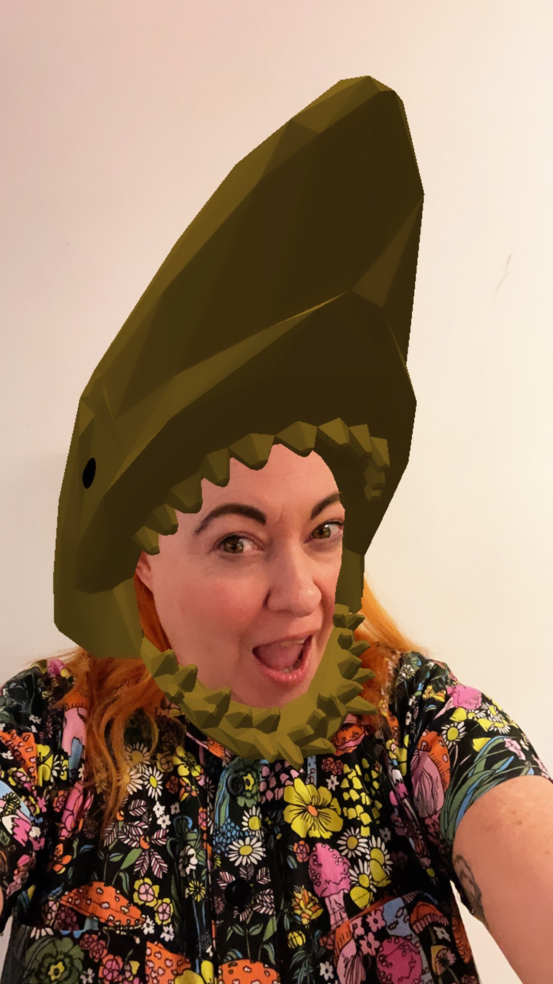

ROCU No Name
Idea - Antlers and Beard, maybe tiny arms on face
3D model - Antlers completed and used for prototyping

Dragon Koi Cave
Ideas - Koi kites/dangling from head or held with hand, Dragon head

Glitch Forest
Idea - Mushroom/Plant growth or mycelium hands

A Little Like Alice
Idea - ???

