FUN PALACE 2018 Marshmallow Catapult
Playing with food is even more fun when you add some skewers and rubber bands - but how many tries will you take to hit the target?

Activity Details
Various designs are available, eg:
http://www.guinnessworldrecords.com/news/2018/1/how-to-make-your-own-marshmallow-catapult-and-potentially-become-a-record-breaker-508784
This one requires gluing (and therefore needs time for the glue to harden). Uses several ice block sticks, a bulldog clip and milk bottle cap.
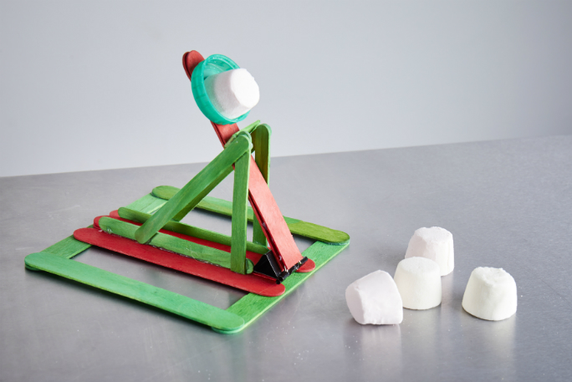
https://www.wikihow.com/Make-a-Marshmallow-Catapult
This one has 3 different designs, the simplest using only 7 skewers, 4 marshmallows (plus one for a projectile), a plastic spoon and some masking tape
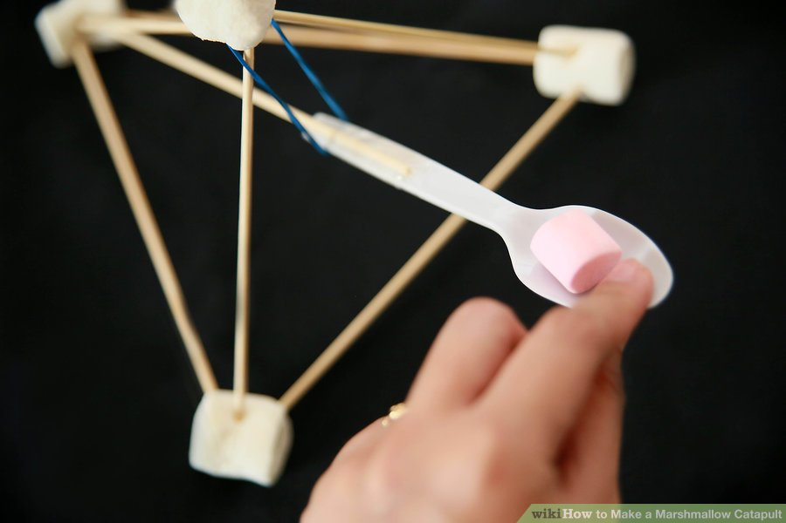
https://www.diynetwork.com/how-to/make-and-decorate/crafts/how-to-make-a-toy-marshmallow-catapult
This one uses no glue, but tongue depressors rather than ice block sticks, held together with rubber bands
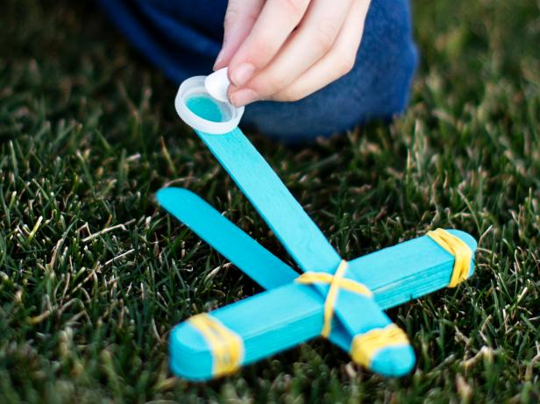
Type
Duration
# Deliveries
Duration

Learning Outcomes & Facilitator notes

Session Plan

Materials Req
Simplest version (using bamboo skewers) For each participant:
- 6 bamboo skewers
- 5 marshmallows
- 1 rubber band
- 1 plastic spoon
- masking tape (a few cm)

Equipment Req
- masking tape
- target (bucket, shallow container or painted on cardboard)

Files

Reflections Learnings

Gallery

