FUN PALACE 2018 Intergalactic Cubby
During this drop in session children will become the engineers that lead the imagining and building of cubbies on an alternate planet. As the engineers you will need to consider the elements (dust storms, heat, wind) when building and choosing materials.

Activity Details
Type drop in
Duration all day
# Deliveries a large scale cardboard cubby will be collaboratively built with children

Activity Criteria

Learning Outcomes & Facilitator notes
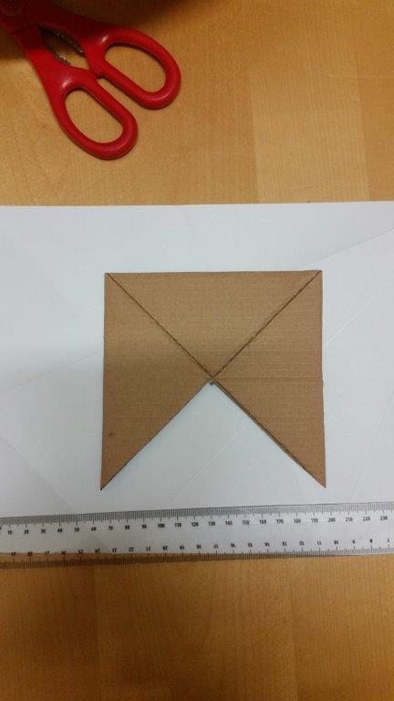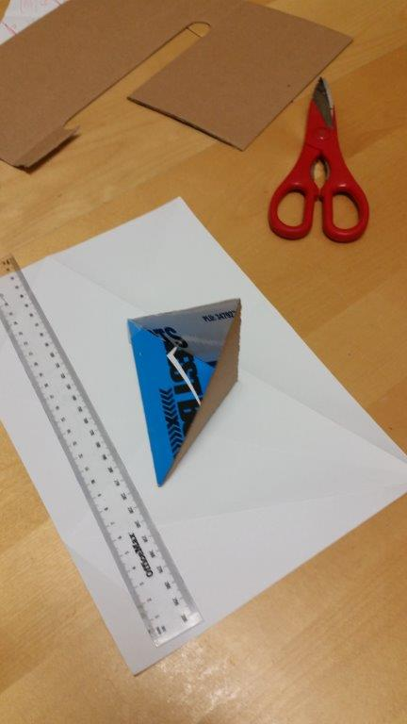
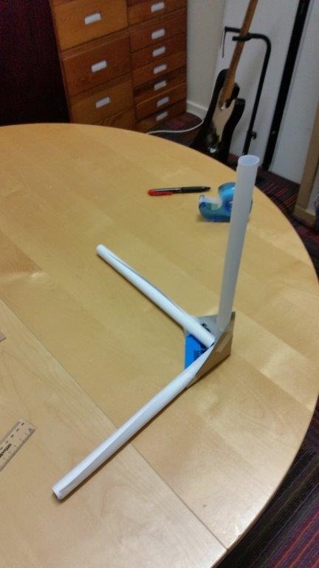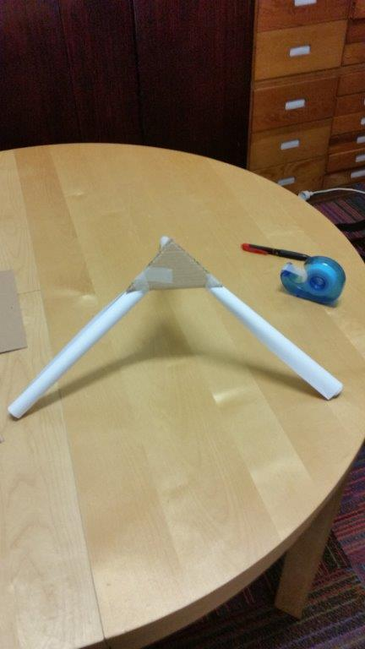

Session Plan

Materials Req
- Confetti
- Fan
- Cardboard boxes
- Cardboard (different types)
- Material
- Coloured paper
- Rolls of paper
- Sticky tape
- Joiners (‘make do’ YPF has some)
- Coloured gels on lights (to represent heat, or cold)

Equipment Req

Files

Reflections Learnings

Gallery

