FUN PALACE 2018 Flubber bouncy balls
This activity was developed and conceived by Jo Ristovski
Make and play with slime and then turn it into a bouncy ball!
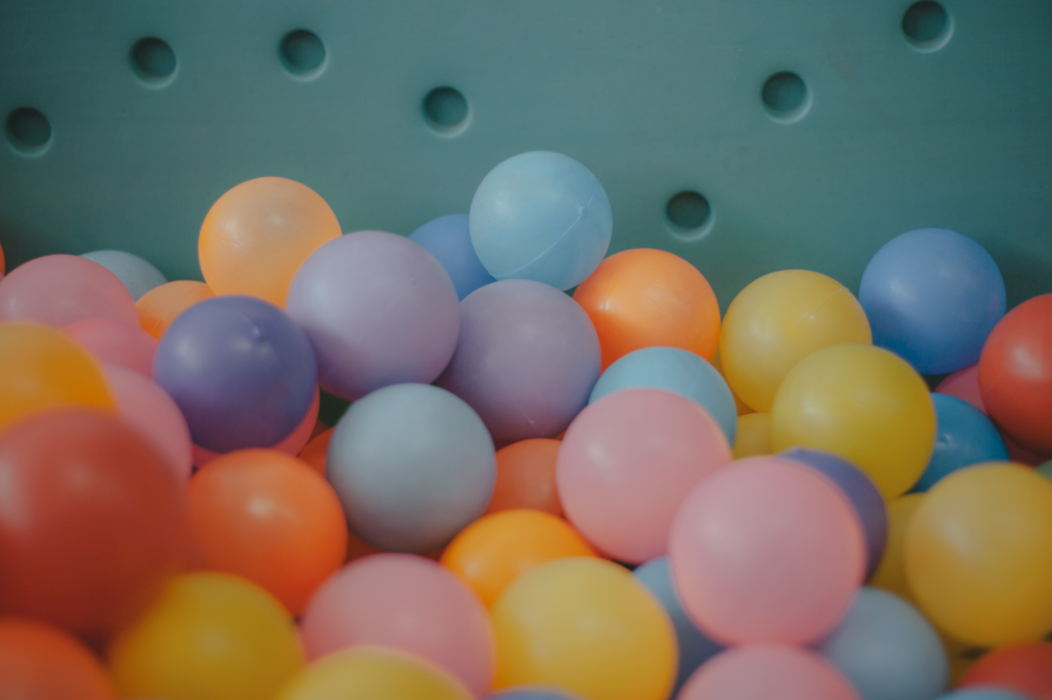

Activity Details
Type walk up facilitated sesssions
Duration 2omin
# Deliveries
You will make and take away a flubber bouncy ball.

Learning Outcomes & Facilitator notes
This workshop is for 8+ and hands will come in contact with borax. There is a need to chat about this at the beginning so that no-one puts this in their mouth or hands that have come in contact.

Session Plan
10 children and parents will come at a time to make flubber bouncy balls.
step 1: everyone gets a cup (with cornflour and glue in it) and then gets to choose a colour (food dye)
step 2: given a small amount of borax and water mixture
step 3: mix using
Step 4: Take it out of cup and play time
Step 5: One by one invited ti dunk into the big plastic bowl full of water and borax mixture.
Step 6: Use hands to roll the mixture into a ball.
Try it out and bounce and take home.
Ask everyone to clean their hands (borax)

Materials Req
* paper cups- one per person
* plastic fork
* 2 large plastic bowls
* PVA Glue:
https://www.spotlightstores.com/craft-hobbies/basic-craft-supplies/glue-adhesives/glue/elmers-school-glue-1-gallon-bottle/BP80427618
* Corn flour:
https://www.woolworths.com.au/shop/productdetails/39128/homebrand-cornflour
* Food dye- multiple colours
* Borax
* Soap in a bowl with paper towel to clean hands
* paddle pop mixer stick
Ingredients ½ Cup Warm Water
1 Tb Borax
1 Tb of Cornstarch
2 Tb White Liquid Glue
Food coloring
Instructions In a cup mix the warm water and the borax. In another cup mix the glue, cornstarch, and food coloring. Pour the glue mixture into the water-borax cup. The glue mixture will harden after 10 seconds; use a fork to take it out of the water. If the glue mixture is still sticky, squish it with your hands and dip it back in the water. Roll the mixture in your hands to make a ball. The more you handle the mixture the firmer it will become. You are done!

Equipment Req
Table and chairs

Reflections Learnings
This workshop was one of the most popular on the day. There was a queue out the front door at different times of the day.It was an easy activity that was very engaging and children then were eager to test out the 'bounce' of the ball.

Gallery

