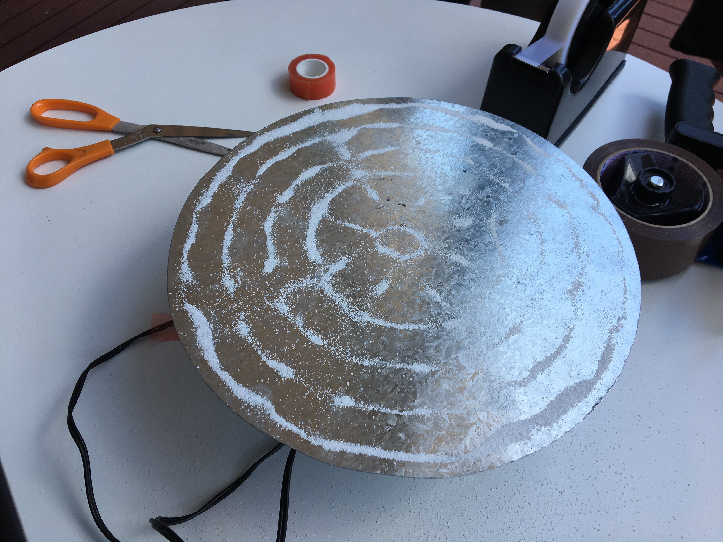
[

Chladni Kerry

Activity Details
Walk Up Science and Art Experiment
#1 per month
20 minutes
PLEASE NOTE: This experiment involves high pitched sounds for a continuous period. If you or your child is sensitive to this please factor in whether or not this programme is appropriate for you

Activity Criteria

Learning Outcomes & Facilitator notes
- Fun fact - Ernst Florens Friedrich Chladni (30 November 1756 – 3 April 1827) was a German physicist and musician. He is sometimes referred to as the father of acoustics.
- Interesting fact for a child/teenager – An Odd Name: They’re named for the German physicist Ernest Chladni who popularized them in the mid-1700s. His name is pronounced: kläd’nêz.
- Interesting fact for an Adult – Instruments made of wood, string, and metal move in complex and nonlinear ways; that's partly why the sounds they make are so rich.
- Ernst Chladni Image
https://www.google.com.au/search?rlz=1C1NHXL_enAU801AU801&biw=1366&bih=657&tbm=isch&sa=1&ei=K8ffW6CpIM6hyAPsgb7oBA&q=ernst+chladni&oq=Ernst+Chla&gs_l=img.1.0.0l3j0i8i30k1j0i24k1l3.1647.4485.0.6833.10.10.0.0.0.0.305.1584.2-6j1.7.0....0...1c.1.64.img..3.7.1584...0i67k1j0i30k1j0i5i30k1.0.XIzxlqFpyR4#imgrc=AwdK8b9RiRJ-tM:

Session Plan
Ensure appropriate applications are installed in your device, such as a function generator. Begin session by introducing the experiment. Discuss materials and equipment required and get the users to feel the vibration that the phone puts out through the speaker. Facilitator to go through the process of building the experiment, pausing to see if anyone has questions as you go. Once you have done this, allow the participants to carry out the experiment themselves (with supervision). Remember to ask for feedback at the end of the session.

Materials Req
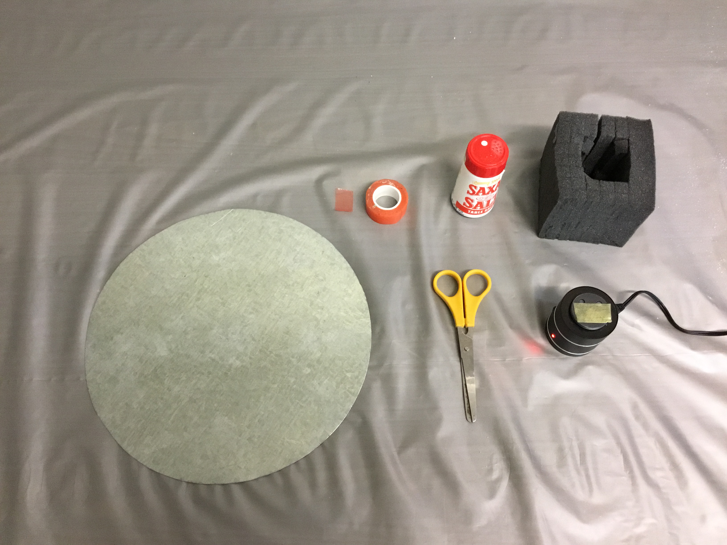Equipment
- Salt
- Rigid surface eg. Metal
- Double sided tape/ Sticky dot
- Foam coverage for speaker (adapt to speaker size)
- Ear protection

Equipment Req
- Contact Speaker and appropriate cords and attachments
- Phone with sound app (to be used for tonal vibrations)
- Scissors

Files

Reflections Learnings
The participants particularly enjoy the patterns created by the vibrations that played out on the metal surface. This experiment brought much joy to those who were in attandance. Next time we hope to enhance the experience by using different coloured salts. We would also like to experiment and trial a number of other materials in place of the salt such as sand, glitter etc.
Things to be aware of during the experiment are, quantities of salt, too much will prevent patterns from forming and ensuring the metal plate is even.

Gallery

Atribution
~~WHITSUNDAY REGIONAL LIBRARIES ~~

