Public sessions: Cardboard Kaiju 2.0 Design Files
The following files contain the new game mechanics and assets for Cardboard Kaiju 2.0

City mat/board
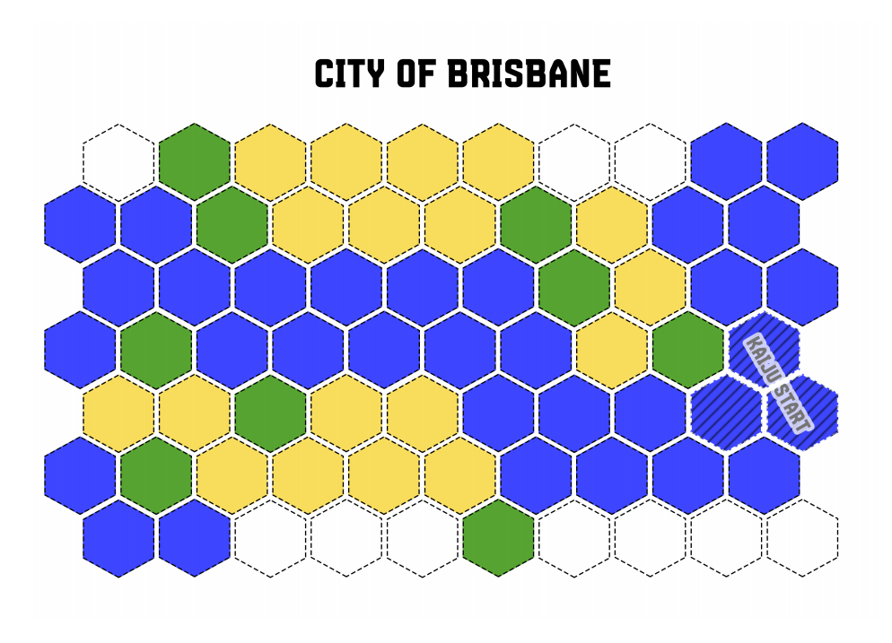

Enrage/support board
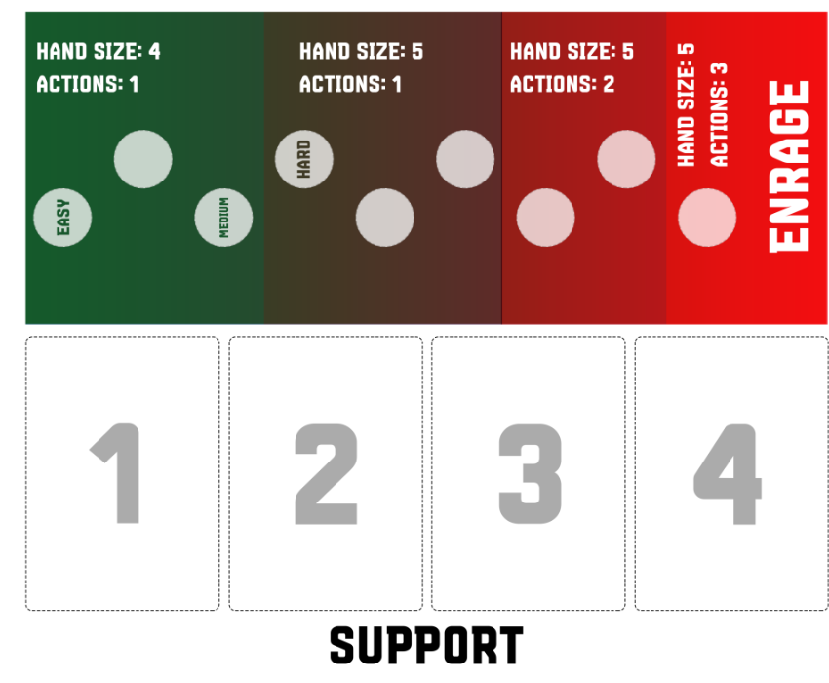

Rule book
cardboard_kaiju_2.0_rules_1_.docx

Card details
cardboard_kaiju_2.0_card_data_2_.xlsx

Sound Files
files from sound design

