Electronics files
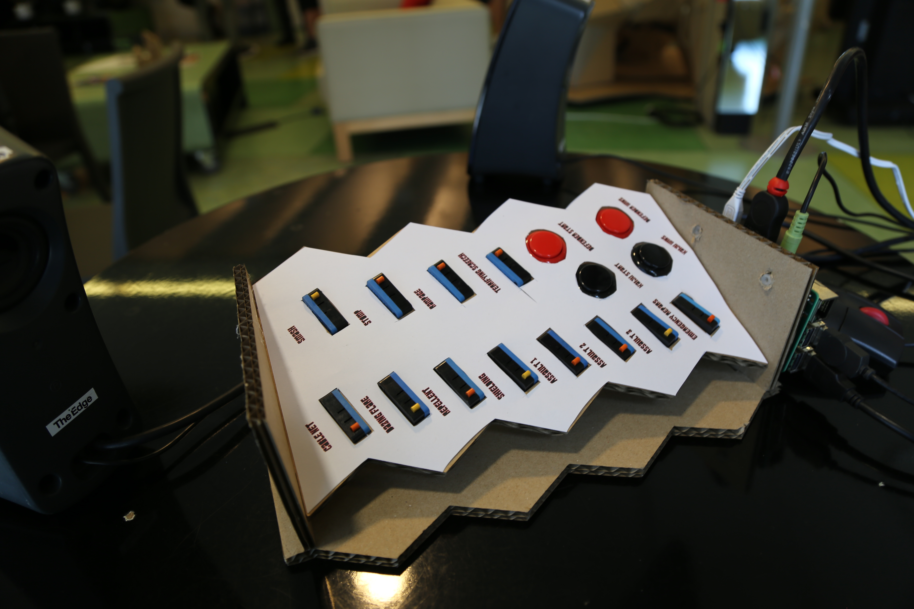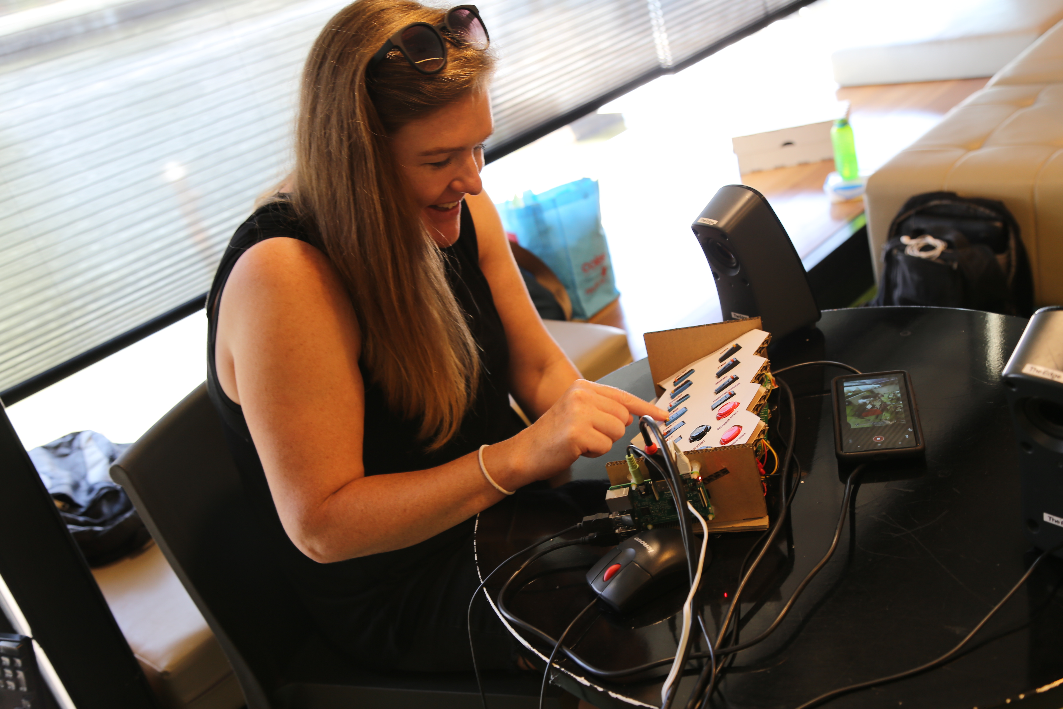
media_boardinstuctions.docx
This document describes the number and type of sounds required. For details on construction see

