Outreach sessions: 3D printing induction (archived - obsolete equipment)
During this session the group of young people will learn how to safely use a 3D printer. They will also design and make a simple badge to wear and take home with them.

Preparation
Introductions
Check that the 3D printers are working
Clear the space from any hazards

The plan
Follow the induction here:
https://wiki.edgeqld.org.au/doku.php?id=facilities:fablab:inductions:3dprinter:start
After learning the basics on Tinkercad the group will focus on designing a small object that will become a badge to wear.
While the badge is printing young people will complete the induction paperwork so that they can book and use the printers in their own time.
Once the badge is printed a back will be attached to make it a badge.

What happened
The group was smaller than we expected this week. There were 3 people that attended. All engaged with working on Tinkercad. They were given the freedom to come up with a design of their own choosing- they all had views on what they wanted to make.
Mick gave them three ways in to creating a design. They were:
- using the shapes in Tinkercad
- going to Thingiverse https://www.thingiverse.com/
- searching for a silhouette and taking it into illustrator and then importing into Tinkercad.
Everyone began with the shapes in Tinkercad and then one young person chose a car from Thingiverse
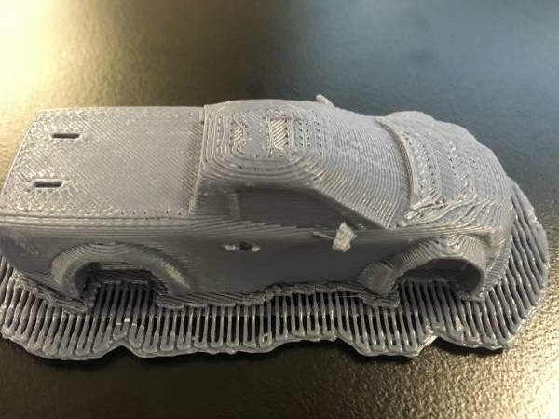
and the other started with a silhouette.
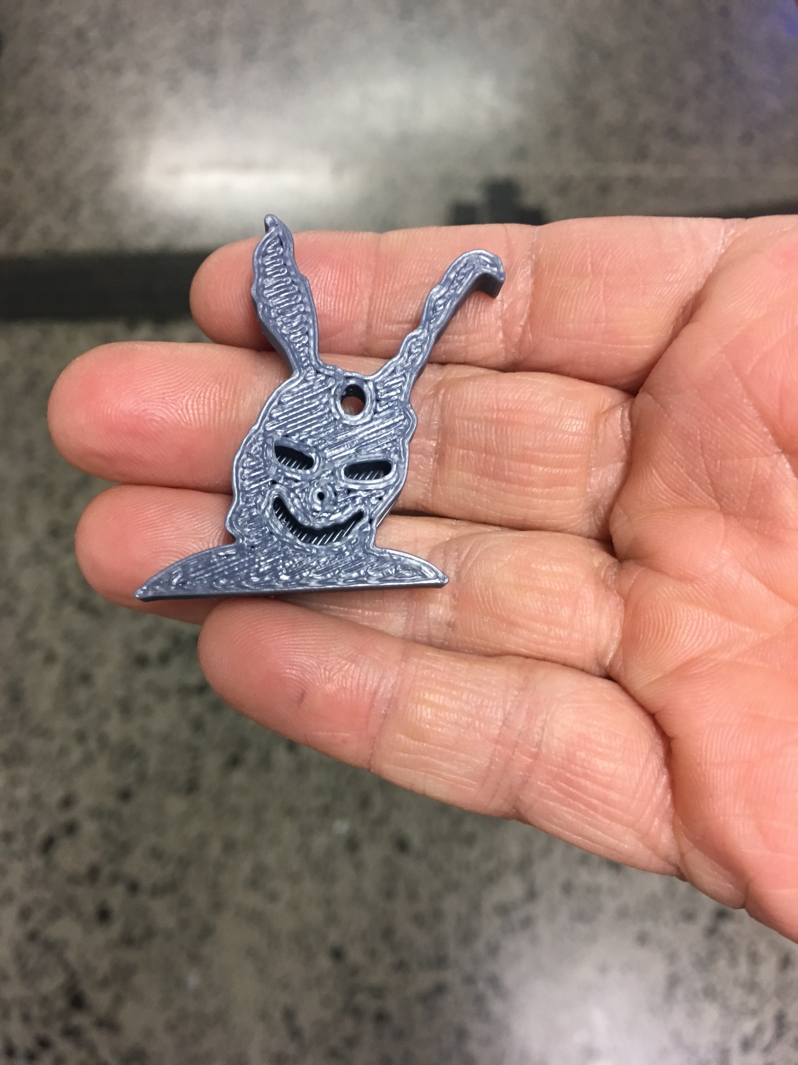
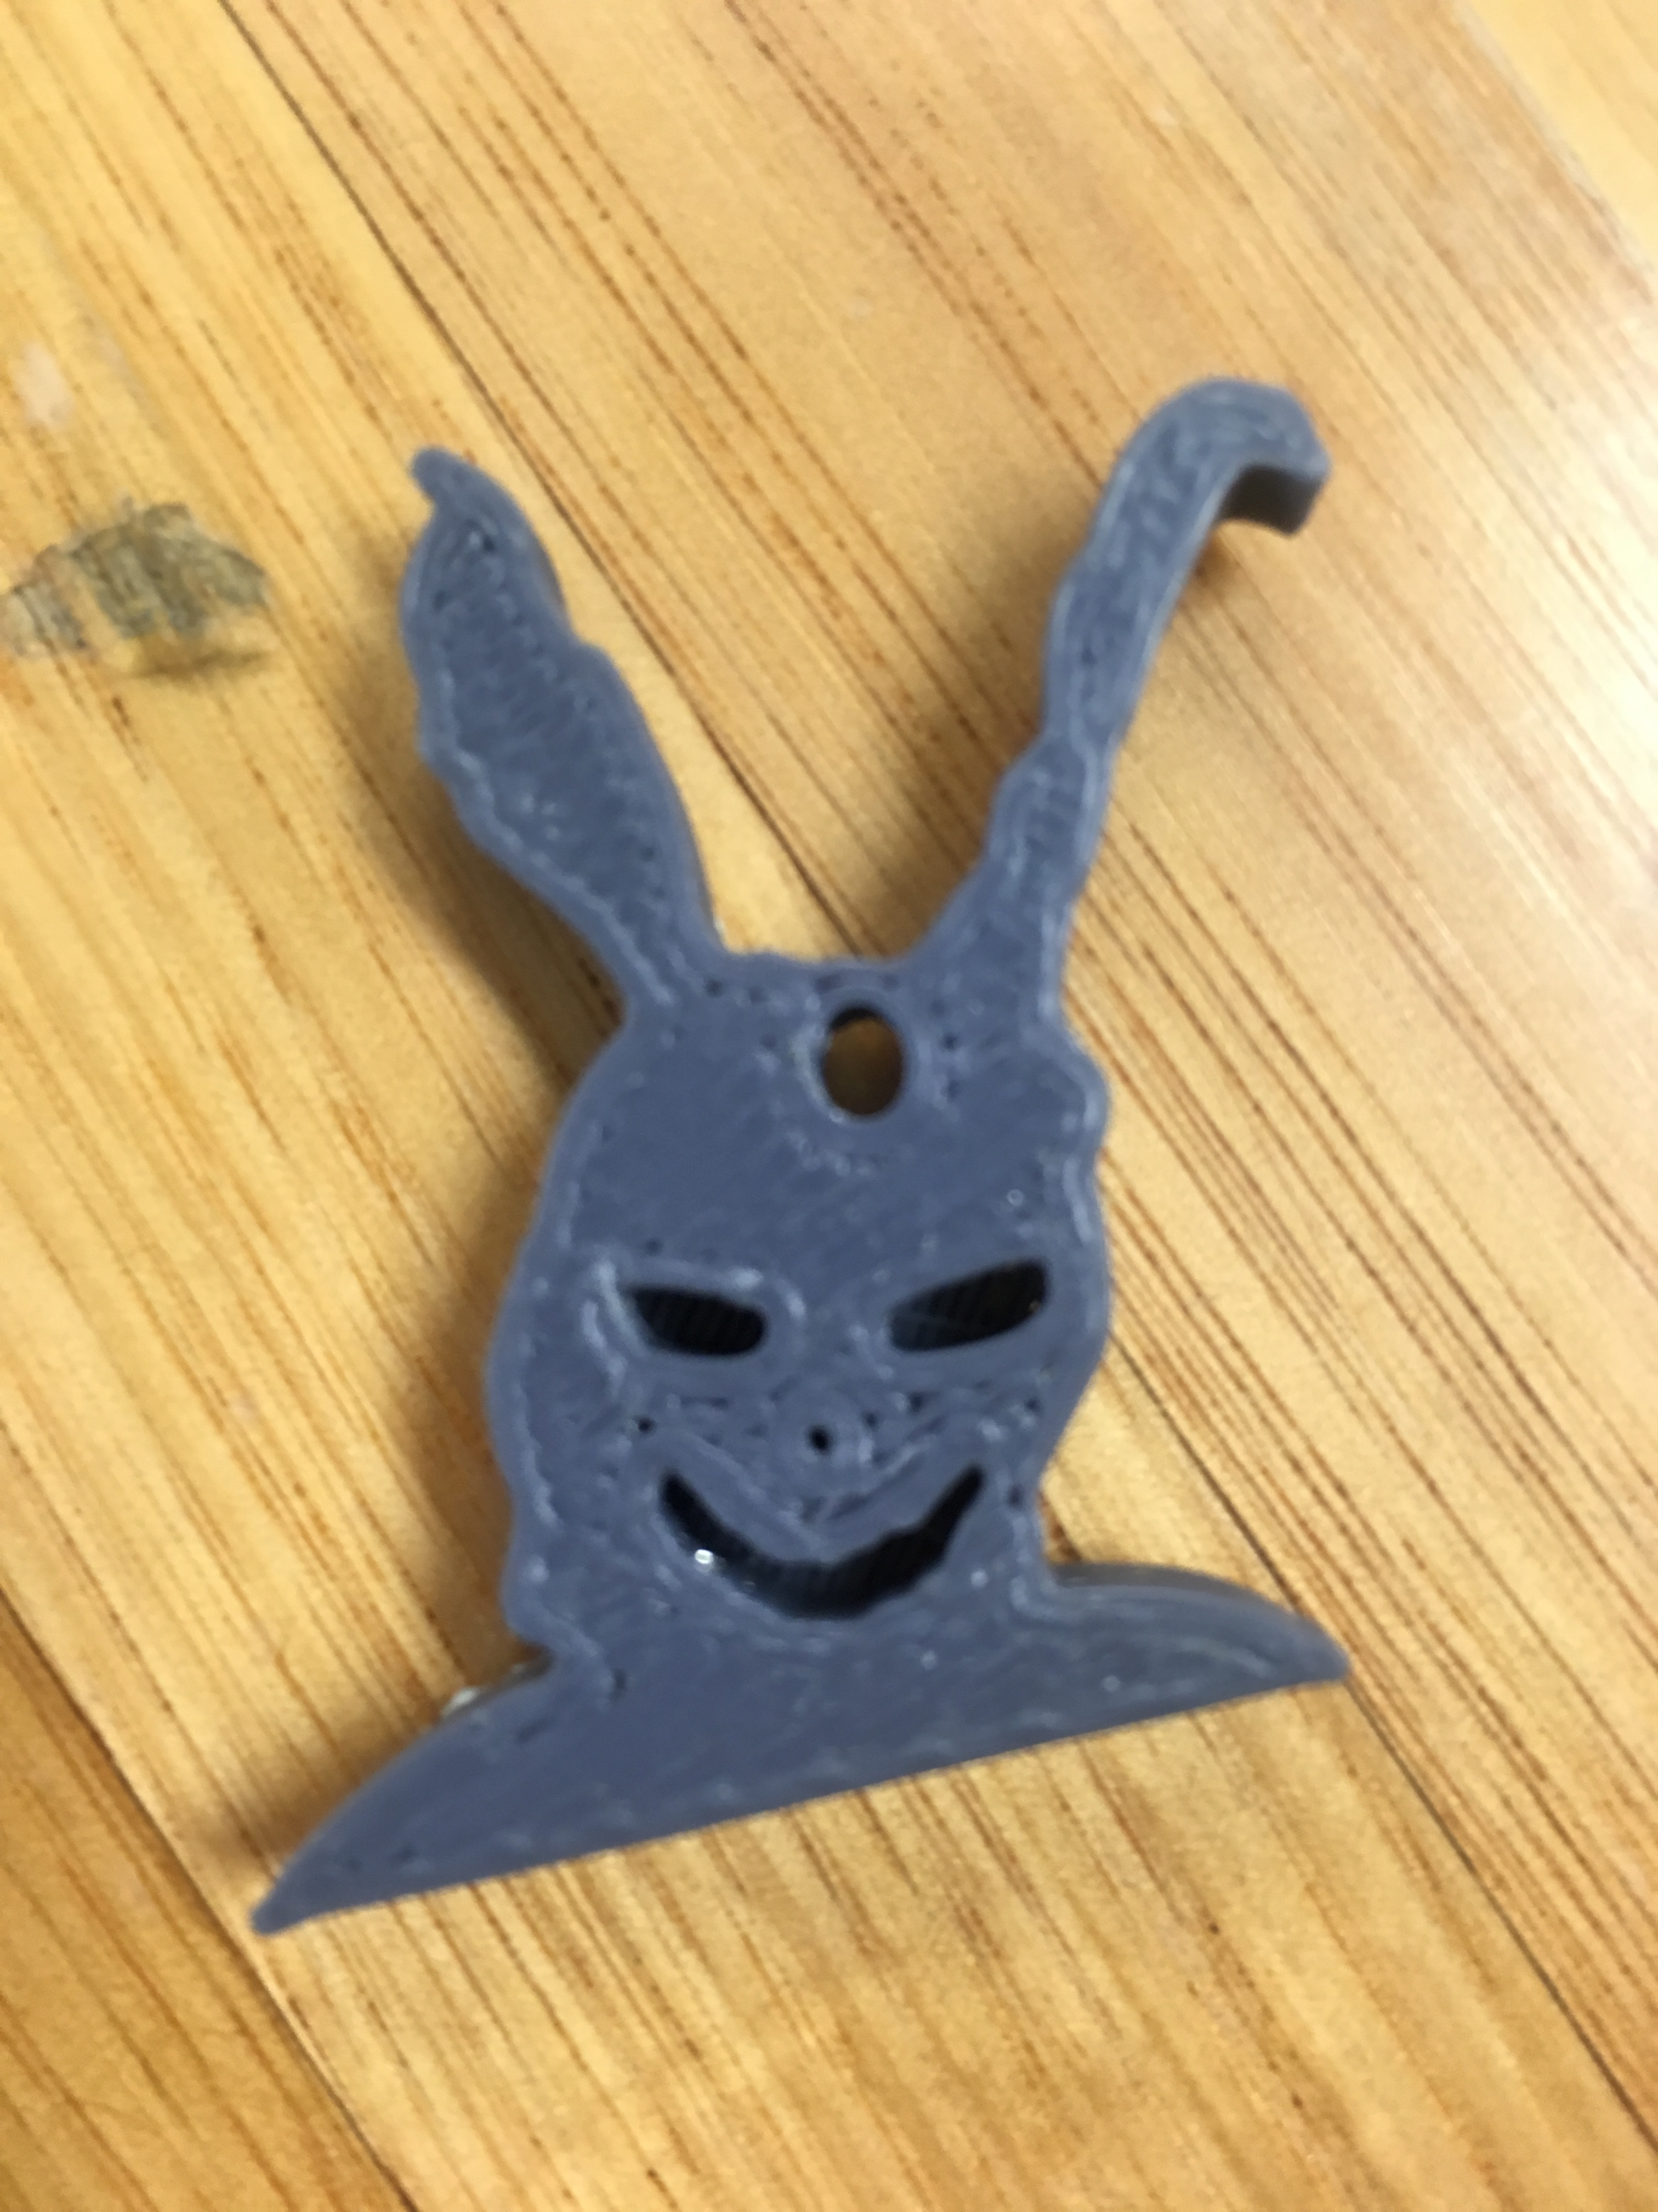
Moving forward to next week. The group may split based on where there interests have progressed to. Go here to see the plan and execution for this next session

Feedback
From a teacher: It’s been great to bring our young people into the edge this term. Really appreciate the relaxed approach all of you have to teaching.

