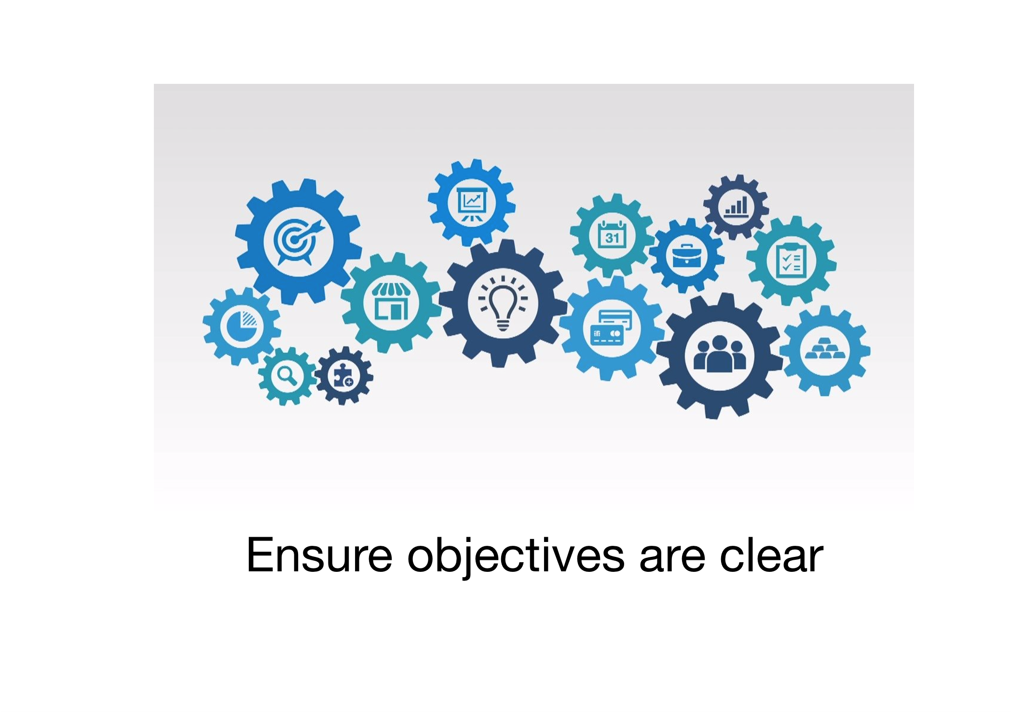

Facilitating discussions and activities
~~HERO-SUBTITLE Strategy 1~~
Graphic courtesy pixabay.com
Visualise facilitating a group activity. Think about how setting out clear objectives for the session might benefit your learners. How might you work this into your session? Contribute your thoughts in the discussion forum below. Please feel free to comment on or reply to any other contributions.
~~HERO-COLORS #A60991 #FFF rgba(255,255,255,0.8) #FFF #FFF~~

