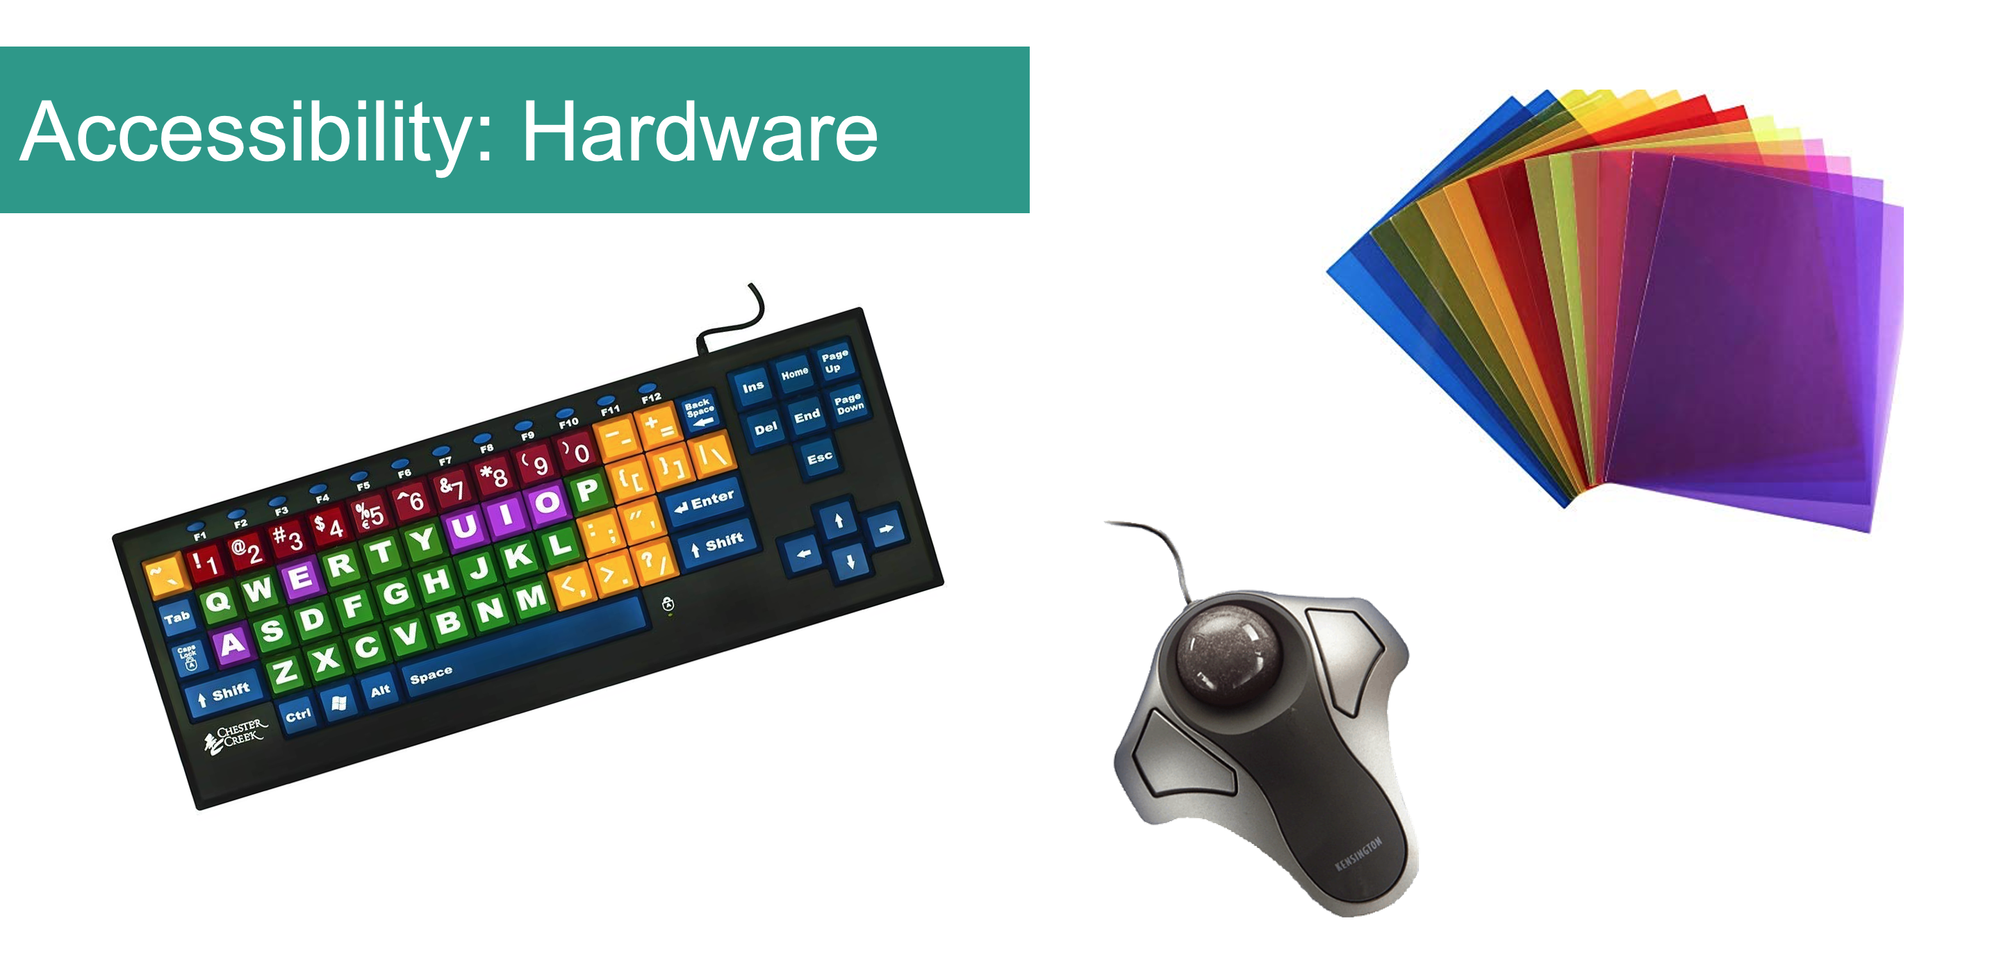

Accessibility features: what do you have in your library?
Do you have accessibility hardware or other features available for client use in your library? In the discussion forum below, share what you have, share some good news stories about the difference it makes to your patrons and perhaps what accessibility tools you might like to acquire in the future.
Please feel free to comment on or reply to any other contributions.
~~HERO-COLORS #A60991 #FFF rgba(255,255,255,0.8) #FFF #FFF~~

