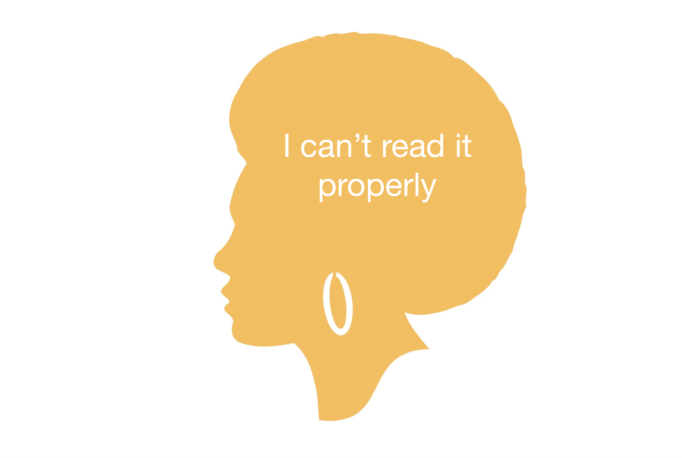

Idea sharing - Barrier 5
Graphic courtesy pixabay.com
In the discussion forum below, contribute your thoughts on how, as a digital mentor, you might assist a client who presents this barrier as a reason for not engaging with the digital world. Please feel free to comment on or reply to any other contributions.
~~HERO-COLORS #A60991 #FFF rgba(255,255,255,0.8) #FFF #FFF~~

