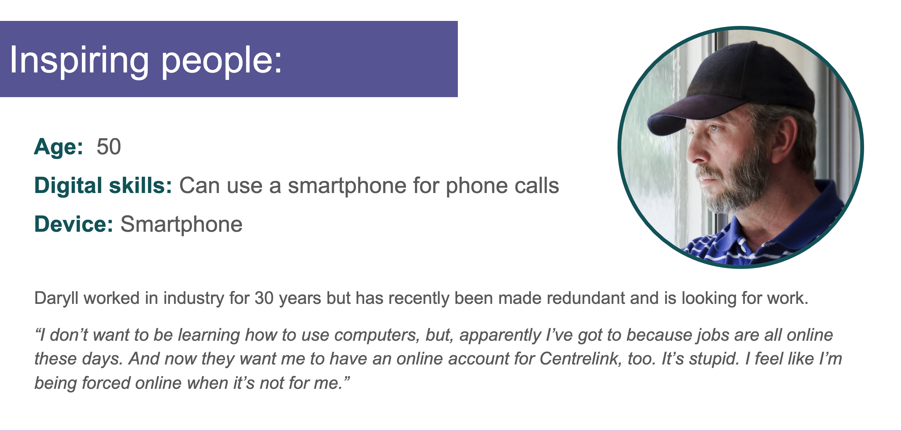

Inspiring Daryll
Based on Daryll's profile above, suggest some ways you could inspire him to get interested in getting online!
Please feel free to comment on or reply to any other contributions.
~~HERO-COLORS #A60991 #FFF rgba(255,255,255,0.8) #FFF #FFF~~

