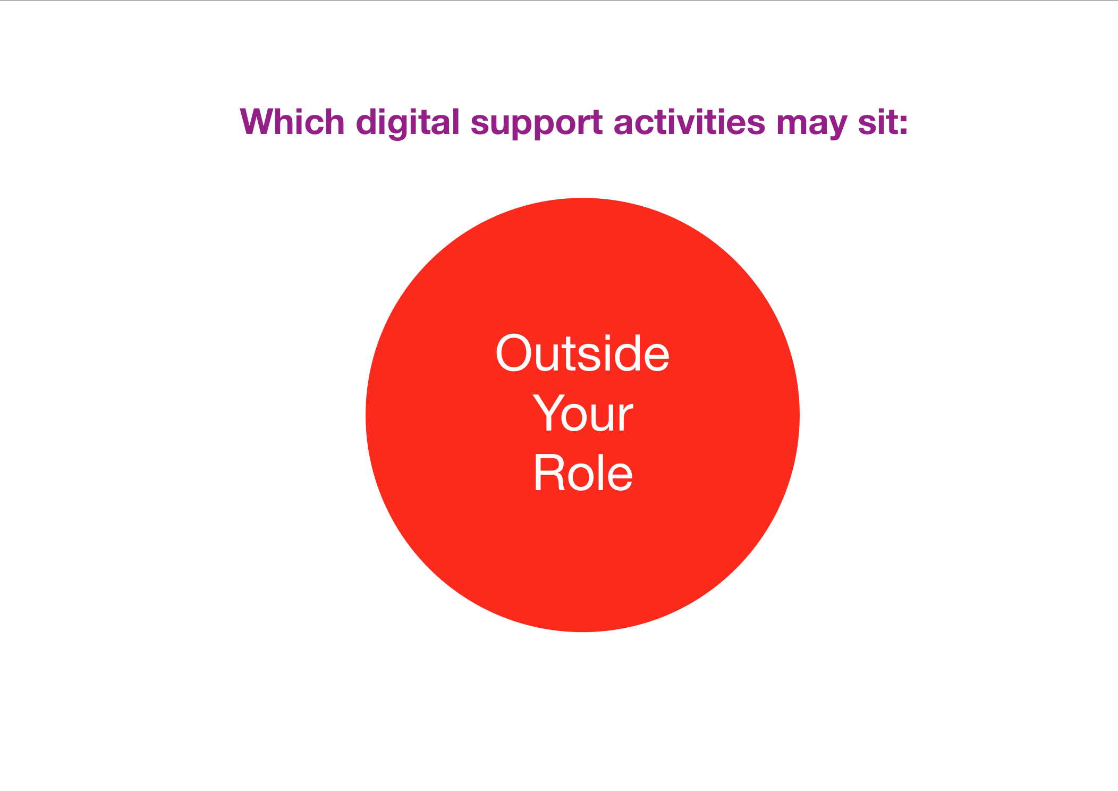

Idea sharing
Contribute your thoughts in the forum below on the types of support you may be asked to provide by a digital learner which you feel might sit outside appropriate provision in your role of digital mentor.
Please feel free to comment on or reply to any other contributions.
~~HERO-COLORS #A60991 #FFF rgba(255,255,255,0.8) #FFF #FFF~~

