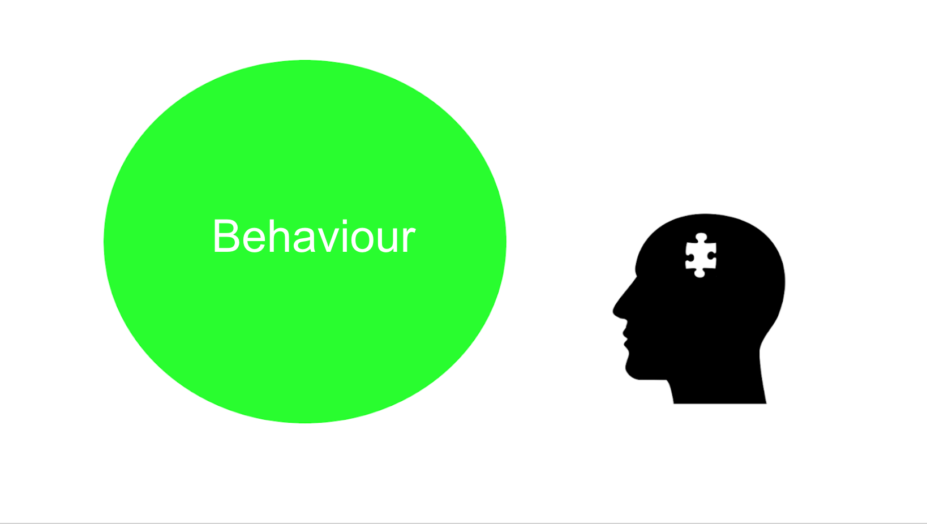

Idea sharing
What behaviours do you think a digital mentor would need to enact to be effective?
Contribute your thoughts to the discussion forum below and see what others have said. Please feel free to comment on or reply to any other contributions.
~~HERO-COLORS #A60991 #FFF rgba(255,255,255,0.8) #FFF #FFF~~

