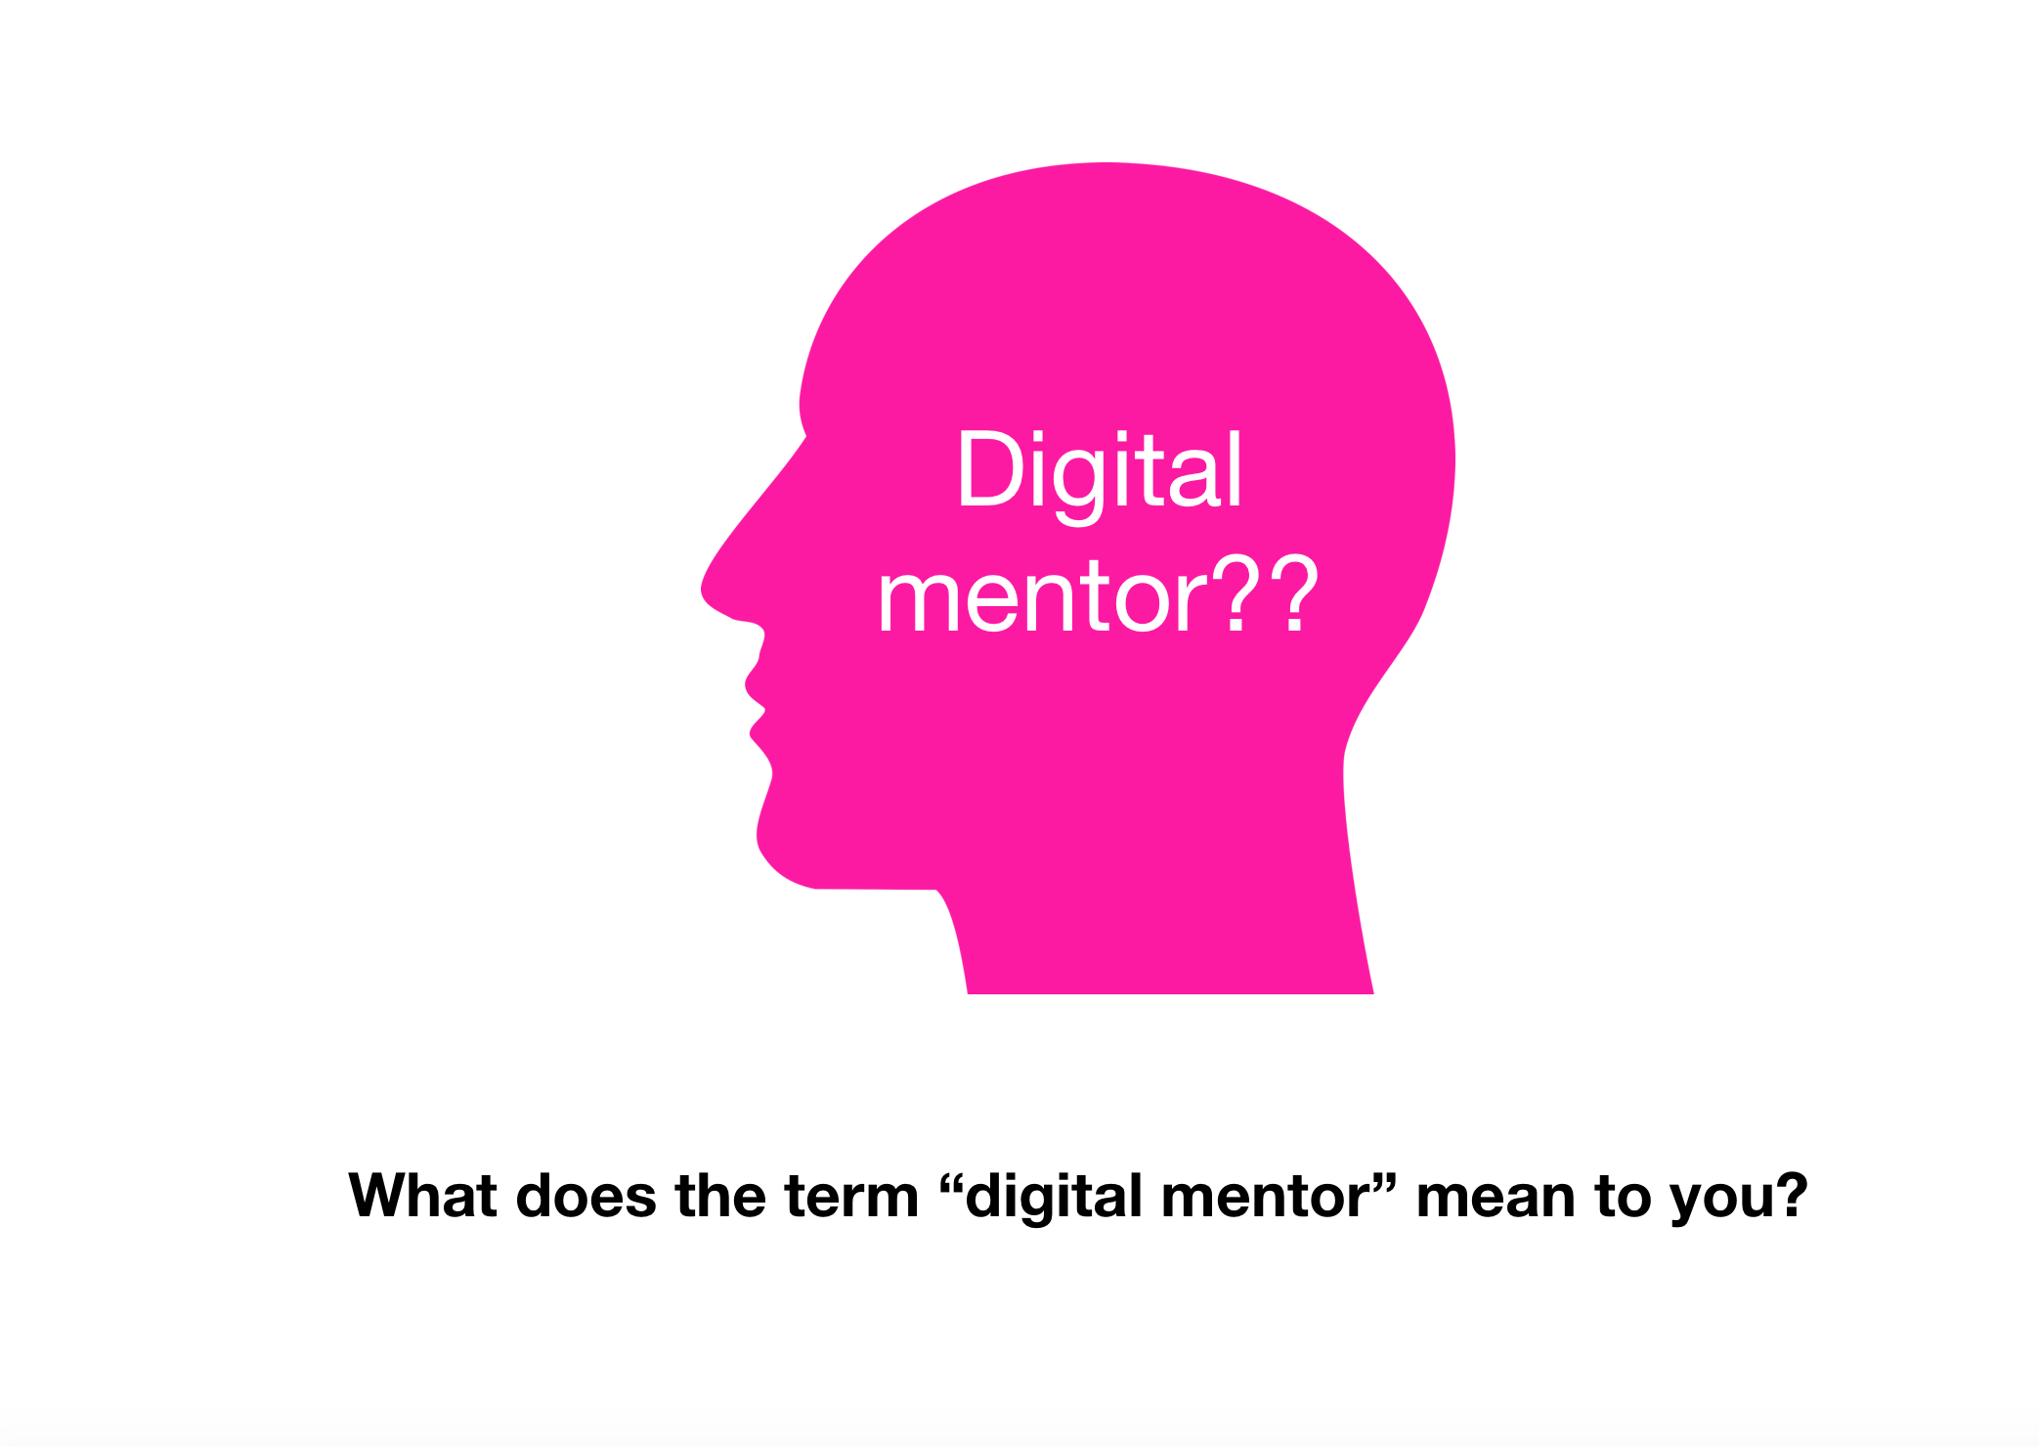

Idea sharing
Graphic courtesy pixabay.com
Contribute 2-3 words which capture your impressions of a Digital Mentor in the discussion forum below. Please feel free to comment on or reply to any other contributions. ~~HERO-COLORS #A60991 #FFF rgba(255,255,255,0.8) #FFF #FFF~~

