Be Connected Digital Mentoring
~~HERO-COLORS #a60991 #FFF #FFF #FFF #FFF~~ ~~HERO-IMAGE 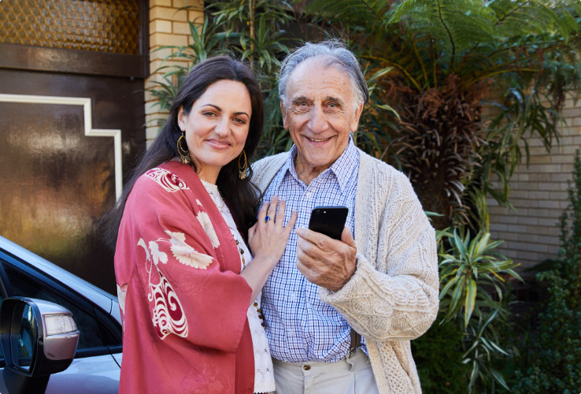~~ ~~HERO-SUBTITLE Completion~~ Please enter your name and organisation in the fields below to register your completion of the the Be Connected Digital Mentor online train-the-trainer program. By submitting your details you acknowledge that you have completed all content across all course modules, including at least 1 post to each discussion activity forum.
To receive your certificate of completion, enter your details into the Certificate of Completion form

