Tablet Charging Stations
Tablet charging stations come in a different range of varieties based on what features you are requiring within your library and how many devices you want to use within the station at once. These features and pricing are typically around:
- Charging multiple devices
- Lockable storage
- Synchronising data to a Mac/PC
A key component to look for is that each USB port needs to have an output of at least 2.1A. Some lower end solutions, while indicating support this output, only actually support it for a single port and not multiple ports simultaneously.
Prices start at $110 for a simple 10 port charger up to several thousands of dollars for 20+ devices, synchronising capabilities and lockable storage.

Low Cost Solutions
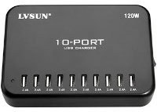
For simple 10 port tablet library setup, Modern teaching aids sells the 120W 10 port USB charger for $110. You can also include a tablet lockable storage tub for $180.
Note: that this does not include the iPad or Android charging cables or allows synchronising to a Mac/PC.

Larger Secure Solutions
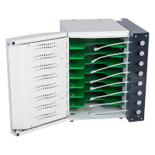
For a more secure configuration, the Putnam series available at MWave.com.au is able to be wall mounted, is made out of steel construction and comes either with lighting or micro-usb cables. Available in 8 bay ($1100) or 16 bay ($1900) configurations.

