Squishy Circuits
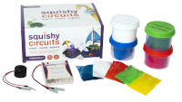
Squishy Circuits uses conductive and insulating play dough to teach the basics of electrical circuits, a perfect blend of play and learning! The play dough kits, projects, and recipes teach problem solving and engineering concepts and inspire creativity and independent thinking.
Recommended Ages | Year 3 to Year 6 (ages 8 to 11)
Product Cost | $55-$65
Where to Purchase | Available from STEM and Electronic stores such as JayCar Electronics

Loanable Kits
State Library does not have kits of this item available for loan to libraries.

Resources
- Squishy Circuits Projects

