Creating Basic Animation in Scratch

Setting the Stage
First thing is we are going to set the stage backdrop from the standard and bland white to a nice image.
Click on the Stage backdrop preview on the bottom right of the window to show the Backdrops tab. Within this tab, we want you to choose a new backdrop using the backdrop add button on the bottom right.
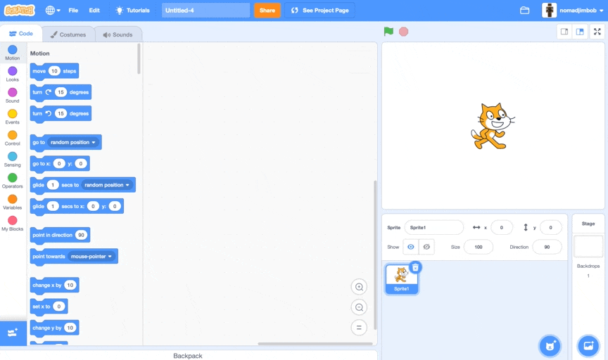

Changing Costumes
Scratch the cat has 2 built-in costumes (Costume 1 and Costume 2) which you can see by clicking on the Scratch the cat sprite and then the Costumes tab.
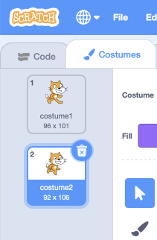
To change the costume of a sprite, we use the Switch costume to block from the Looks palette.
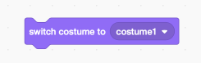
For us to create an animation, we need to change between the costumes at a certain speed. Here we are going to switch between Costume 1 and Costume 2, adding a Wait block from the Control palette, and setting the wait time to half a second (0.5).
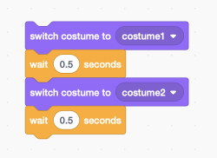
Now that we have the animation code done, we need to wrap it in a Forever block which can be found under the Control palette, this way it will repeat for the duration of our program.
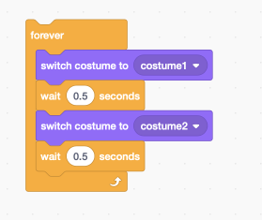
Finally we need to connect our code to an event. As we want this animation to begin as soon as the user presses the Green Flag, lets bring out the When Green Flag Clicked hat from the Events palette and connect our animation code underneath.
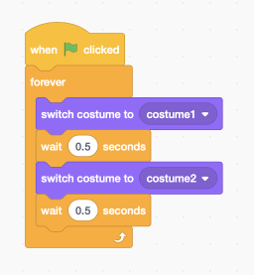
Our animation code is now done. We can test it out by pressing the Green Flag of our project!


