Pro-Bot
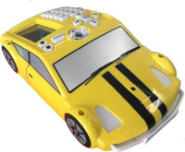
Pro-Bot is the grown up version of the Bee-Bot and can be programmed using robotic controls on the car or through Logo programming. This race car designed bot allows students to enter commands via a set of arrow and number keys mounted on the back. Plan a route for the Pro-Bot and press the corresponding keypad controls then press GO. The Pro-Bot also allows repeat loops and has bumper and light sensors to take programming to the next level.
Recommended Ages | Year 3 to Year 6 (ages 9 to 12)
Product Cost | $250-$300 per unit
Where to Purchase | Bee-Bots and Blue-Bots can be purchased from Modern Teaching Aides

Product Requirements
- Each Bot uses 3AA batteries

Loanable Kits
State Library does not have kits of this item available for loan to libraries.

Activities
- Draw a Butterfly

