PowerUp 3.0 Paper Plane Time Challenge
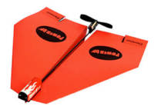
Activity developed by Redland City Council Libraries

Details
Age group | Year 3+ (ages 8+)
Method | Drop-in activity
Participant to facilitator ratio | 2 staff available
Duration | 1 hour 10 mins

Aim/Key Learning
Participants will work individually to fine tune the design of a paper plane in an attempt to have the longest flight time with a Bluetooth propeller attached. The planes will be controlled by a connected tablet.
This activity encourages participants to think creatively to produce a paper plane that will fly the furthest given a set of pre- determined parameters and control the plane using the tablet.

Preparation and Materials Required
- Paper
- Paperclips
- Bulldog clips
- Scissors
- Gaffer Tape for marking distance
- PowerUp 3.0 bluetooth propellers
- Tokens
- Stopwatch (or smartphone)
- Organise tablets and ensure the PowerUp app is installed
- Ensure all parts for the remote control paper planes are in the box
- Charge the tablets
- Set up the flying area by taping off a no-walk zone

Activity Steps

1. Instruction and Demonstration
Time: 15 min
Introduce all staff members; speak about what the activity is, what we will go through today and what will be achieved in the timeframe.
- Housekeeping (toilets, emergencies etc.)
- Hand out tokens as participants enter.
- Show video: https://www.youtube.com/watch?v=d0T-AicGVXs
- Demonstration of Bluetooth Paper Plane
- Explain rules:
  - Judge’s decision is final
  - Three tokens only per participant. Each token represents a small amount of ‘bonus’ flight time.
  - The decision at flight time to use tokens is final. Participants will need to weigh up if they should use a token for a longer flight time or save them for upcoming rounds.
  - If flight times in the following rounds are shorter than previous recorded times the past results are null and void. The environment is a major player in the conditions at the time of flying.
  - Participants are given one minute grace period to find the best weather conditions – after the minute the participant is automatically disqualified.
  - New planes cannot be made. If a plane crashes amendments such as perfecting folding creases and adjusting the rudder and elevators as well as weights is allowed.
  - The same paper plane design is to be used by all participants.
  - The placement of the Bluetooth propeller will be the same on each
plane.

2. Folding and Testing Planes
Time: 20 min
- Have participants make the paper plane by using the power up 3.0 design instructions at https://www.youtube.com/watch?v=Am9HxLY_WYU
- Allow participants to test the design and prototype any alterations desired to increase fly time.
- Encourage participants to adapt design, adjusting elevators, sharpness of creases, plane size, etc.

3. Time Challenge
Time: 30 min
- Run 'knockout' rounds of plane flights, timing each flight with the stopwatch. Each individual has their turn until two are remaining for the final round.
- If possible, this activity should be run in a large space or outdoors (during calm weather)
- Staff may decide whether to provide a small prize to the overall winner, or post their photo announcing them as the winner of the competition
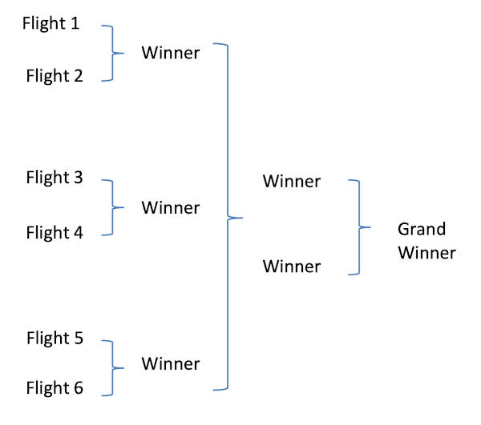

4. Evaluation and Closing
Time: 5 min
At the end of the session, ask for volunteers to share their learnings or how they found the session. Thank everyone for their participation and team work.

Additional Inspiration and Resources
- Paper plane folding tips and tricks (Plane stability)

Loanable Kits
State Library has kits of this item available for loan to libraries within the Regional Libraries Queensland and Indigenous Knowledge Centres network. Libraries can place a reservation through the Aurora catalogue (availability is subject to existing reservations, loans and associated return dates).
The kits are for use by patrons within the library only, as part of supervised library programming. They will not be listed in the public online catalogue for personal reservation.
Please contact Access Services, or phone 07 3842 9014 with any queries.

Loanable Kits
State Library does not have kits of this item available for loan to libraries.

