Keyframe Programming

Creating a New Project
On the Getting Started window, select New project…, If the window does not appear, select New project… from the File menu
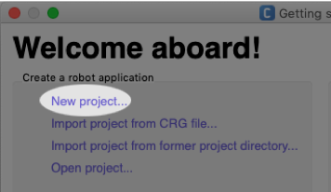 | 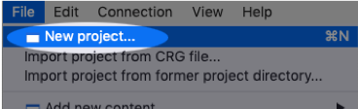

Connecting to the NAO
With both your NAO and computer connected to the same wireless network, click the Connect to  button in the toolbar or select Connect to… from the Connection menu
A list of virtual/simulated and physical robots will be displayed. If your NAO appears in the list and is green, highlight it and press the select button.
A real robot - not ready to connect to.  If the robot stays in this state, try restarting the NAO and Choregraphe | A real robot - ready to connect to. | 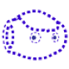A virtual robot - you can connect to this robot.  Some commands in Choregraphe will not be available

