KANO
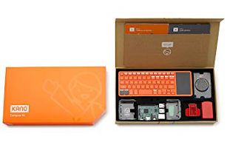
Kano is a computer anyone can make. Kano's mission is to give young people – and the young at heart – a simple, fun way to make and play with technology, and take control of the world around them.
When you build your own Kano computer, you get a real computer, powered by Raspberry Pi 3 and Kano OS. You get all the apps and programs you need. You get a powerful learn-to-code tool, designed to unlock potential, and unleash creativity.
Recommended Ages | Year 3 to 6 (ages 9 to 12)
Product Cost | KANO Basic Set $340-$370  KANO Complete Set $480-$530  Additional Coding Kits $150-$200
Where to Purchase | The KANO can be purchased from electronic stores such as Core Electronics

Product Requirements
- The Basic set requires a HDMI capable display

Loanable Kits
State Library has kits of this item available for loan to libraries within the Regional Libraries Queensland and Indigenous Knowledge Centres network. Libraries can place a reservation through the Aurora catalogue (availability is subject to existing reservations, loans and associated return dates).
The kits are for use by patrons within the library only, as part of supervised library programming. They will not be listed in the public online catalogue for personal reservation.
Please contact Access Services, or phone 07 3842 9014 with any queries.

Kit Contents
- 4 x KANO Complete set

Tips

Resetting Kano OS to Factory Settings
If you want to pass on the fun and give your Computer Kit to someone else, it's easy to remove your data and restore it to factory settings.
- Find the Terminal app on your Kano dashboard.
- From the command line, type sudo kano-init reset and press enter.
- If it asks for a password, type kano and press enter.
That's it! Your Computer kit will be reset to factory settings the next time you start up the computer!

