Jimu
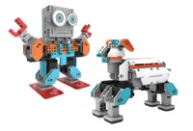
Jimu is a great introduction to robotics and coding, with easy to follow instructions, you can use a tablet to move the robot around, record and playback poses and detect objects using its infrared sensors.
Jimu comes in various kits to construct robots, rovers and various animals.
Recommended Ages | Year 2 to Year 5 (ages 7 to 10)
Product Cost | Kits start at $200
Where to Purchase | Jimu can be purchased from Officeworks or Wireless1

Product Requirements
- A tablet is required

Loanable Kits
State Library does not have kits of this item available for loan to libraries.

