Drones
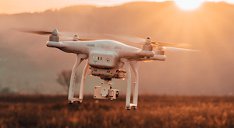
Drones can not only provide a lot of fun for recreational purposes, they can also be used in commercial applications and have the possibility to interfere or cause hazards with other aircraft, buildings and equipment.
CASA Rules Apply
Before using a drone, please visit the drones information page on the CASA website which can provide you information on how, where and requirements of flying a drone.
Recommended Ages | Year 8+ (ages 13+)
Product Cost | Drones start at $200+
Where to Purchase | Most electronics and hobby shops such as JB Hifi

Product Requirements
- Drones with cameras require a smartphone

Loanable Kits
State Library has kits of this item available for loan to libraries within the Regional Libraries Queensland and Indigenous Knowledge Centres network. Libraries can place a reservation through the Aurora catalogue (availability is subject to existing reservations, loans and associated return dates).
The kits are for use by patrons within the library only, as part of supervised library programming. They will not be listed in the public online catalogue for personal reservation.
Please contact Access Services, or phone 07 3842 9014 with any queries.

Kit Contents
- 4 x DJI Spark Drones (no smartphones supplied)

