Botley
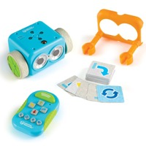
Botley introduces coding in an easy, friendly way for children as young as 5 with advanced features that the children can tap into as their skill grows.
Botley does not require a phone or tablet, children interact with the robot using coding cards, a remote control and obstacles, programmed to follow looping commands and use if/then logic.
Recommended Ages | Prep to Year 3 (ages 5 to 8)
Product Cost | $100 per unit
Where to Purchase | Botley can be purchased from Funtastic

Loanable Kits
State Library does not have kits of this item available for loan to libraries.

