BigKeys LX
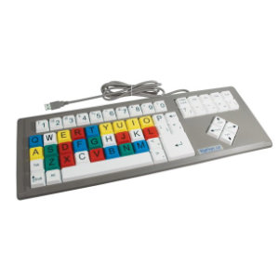
BigKeys XL is a standard keyboard with 1“ square keys, great for small kids or people who struggle to use a standard size keyboard.
Available in 2 layouts, the standard QWERTY and ABC and in 4 colour combinations, White, yellow or multicoloured keys with black lettering and black keys with white lettering.
No special software is required and works with Mac or PC using a USB connection.
Recommended Ages | (ages 6+)
Product Cost | $270
Where to Purchase | Spectronics

