3D scanning
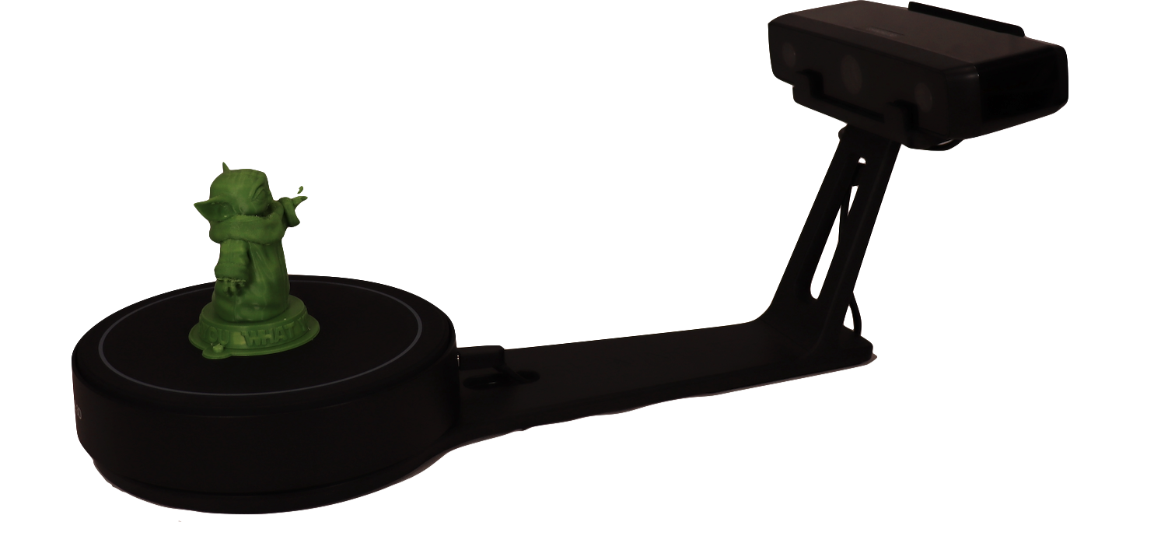
3D scanners enable you to take a digital scan of a real world.
They work by placing a small object on a turntable, which rotates whilst the scanner throws a beam of light ont the object to digitally “feel” the shape of it, which is then recorded and compiled to and turn the 'real' object into a digital object. Examples of ways digital objects created by an 3D scanner could be used include scanning historical items for inclusion in an online virtual gallery, digital oObjects for use in Virtual Reality, digital objects for use in 360 video production, and many more.
The scanner is easy and safe to use and produces high quality scans in fine detail.
Recommended Ages | 13-adult
Product Cost | $3100
Where to Purchase | Alpha Kits can be purchased from Modern Teaching Aids

Product Requirements
The 3D scanner requires a PC on which it's companion software, EXScan, can be installed.

Loanable Kits
State Library has kits of this item available for loan to libraries within the Regional Libraries Queensland and Indigenous Knowledge Centres network. Libraries can place a reservation through the Aurora catalogue (availability is subject to existing reservations, loans and associated return dates).
The kits are for use by patrons within the library only, as part of supervised library programming. They will not be listed in the public online catalogue for personal reservation.
Please contact Access Services, or phone 07 3842 9014 with any queries.

Resources
- EinScan-SE 3D Scanner Setup Tutorial video

