Tech Savvy Regional Queensland
Tech Savvy Regional Queensland is a program that provides grant funding to Regional Councils to deliver digital inclusive programing through their library services that will provide opportunities for their respective community to embrace digital technology.

Resources
The Digital Literacy wiki contains a training resources collection which links to various websites, including Telstra and Microsoft, containing a lot of diverse training topics for a wide range of ages and abilities.

Examples

Cook Shire Libraries
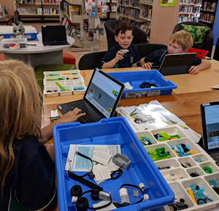
Using Tech Savvy Regional Queensland grant funding, Cook Shire Council partnered with the local schools to facilitate STEM sessions at the Cooktown and Bloomfield libraries using the LEGO WeDo, engaging youth to build confidence, digital and motor skill development with coding and robotics. In these sessions, children built and coded LEGO WeDo slugs, helicopters and fans.

Bulloo Shire Library
Bulloo Shire Council used Tech Savvy Regional Queensland grant funding to run their It Won’t Byte program, aiming at teaching older residents how to use technology to bridge the distance between their friends, family and everyday services.
Becoming proficient in the use of online communication, web access, use of social media, participants where able to connect with friends and family using Video calling apps and FaceBook.
Engaging the regions Director of Nursing and Anglicare to support the initiative, information sessions around My Heath Record and My Aged Care which is important for the targeted age group, with 100% of participants now being registered with My Health Record accounts.
Also ran through the program was digital storage and preservation activities, the sharing of stories and history which provided a therapeutic benefit to the participants.

