Queensland Minecraft
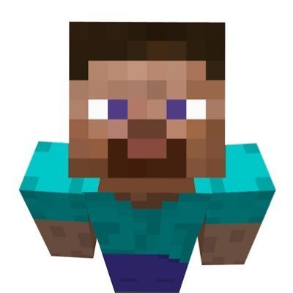
Queensland Minecraft was an online virtual platform used by libraries for a wide range of activities, events and programs as well as being available for its users to challenge themselves in a large community-driven role-playing game.
The program ended at the end of 2020.
Since its closure, the Drustcraft server has been created by staff and players to ensure that the Queensland Minecraft community and spirit lives on.

Guides
You can find some how-to constructions guides on the Minecraft wiki page.

