Digital Literacy
Binbee kurri, and welcome to the State Library Digital Literacy wiki. Here you will find resources available for sharing in your library, school or organisation.
Terminology used on this wiki. Editors, please follow the guidelines when editing this wiki.
COVID 19 Cleaning Advice

Planning
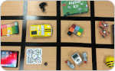  Technology Matrix - A matrix of technologies located on this wiki for libraries to know what technology that should purchase now and into the future based on patrons growth | 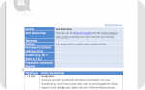  Activity Planner - This template contains all the information to create a workshop in your library including the resources you will need, participants to facilitators ratios, timing, team building activities and evaluation details
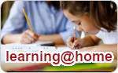  learning@home - The Department of Education has a number of online tools and resources to support students | 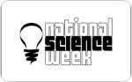  Science - Links that support education around science topics

Technology Resources
A - D  Alpha Kit  Android (Tablets)  Augmented Reality  Bee-Bots & Blue-Bots  Botley  BRIO construction Kit  bristle_bots  chibitronics  Clip Circuit Electrolab  Code-A-Pillar  CodeyBot  Computer Hardware (Siganto)  Cubelets  Cubetto  Cue  Dash & Dot  Drones | E - O  Edison  Engino architecture STEM kit  EZ-Robot  Finch  Google Expeditions  Hummingbird Kit  HTC Vive  IndigiSTEM  iPad (Tablets)  Internet of Things (IOT)  Jimu  KANO  LEEDR Multi Touch Hub  LEGO MindStorms  LEGO Spike  LEGO WeDo  LittleBits  MakeBlock (mBot)  Makeblock Neuron  Makedo  Minecraft  NAO  Oculus Quest  Ozobot | P - Z  Photon  picoboard  PowerUp Paper Planes  Preservation Stations  Pro-Bot  raspberry_pi  Scratch  Scratch Jr  Skoog  Snap Circuits  Sphero  Sphero Specdrums  Squishy Circuits  Storytelling with STEM  Tablets  TAPit  ThinkFun  Turing Tumble  Unity  Vex Battlebots construct  Virtual Reality  Xbox | #  360 Video  3Doodler

State Library Programs
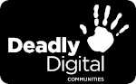
Deadly Digital Communities, community-based digital literacy and technology training over two years to 26 remote and regional Aboriginal and Torres Strait Islander communities in Queensland.
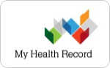
In partnership with the Australian Library and Information Association and the Australian Digital Health Agency, My Health Record - Consumer health information in libraries is a train the trainer program to help build the confidence and knowledge of public library and IKC staff to support clients to access the My Health Record online portal.

Previous

Be Connected Digital Mentor training is a train the trainer program up-skilling library staff across the state to be Digital Mentors, enabling them to confidently deliver Be Connected training sessions and other digital literacy initiatives to their communities.
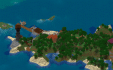
Queensland Minecraft is researching the history and mapping structures within communities and constructing them in the 3D world of Minecraft.
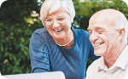
Tech Savvy Seniors Queensland is providing seniors with the opportunity to participate in free digital technology training sessions that will develop their skills and confidence to use technology.
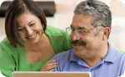
Tech Savvy Regional Queensland was a program that provides grant funding to Regional Councils to deliver digital inclusive programing through their library services that will provide opportunities for their respective community to embrace digital technology.
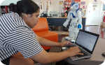
MessageBot was a project to engage Aboriginal and Torres Strait Islanders within your community to build their digital skills through programming cultural content using technology that travels and shares messages between communities.
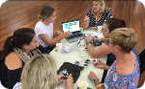
Skilling our Future was a partnership between RDA DDSW and State Library, delivering digital inclusion programming through public libraries in the Darling Downs and South West region to engage with coding and robotics.

Binbee kurri, pronounced Bin-bee curry, means good day in the Ganulu language. The Ganuli language is found at Comet River, Central Queensland. You can find more Indigenous greetings from the State Library Say G'day wordlist.
~~HERO-IMAGE 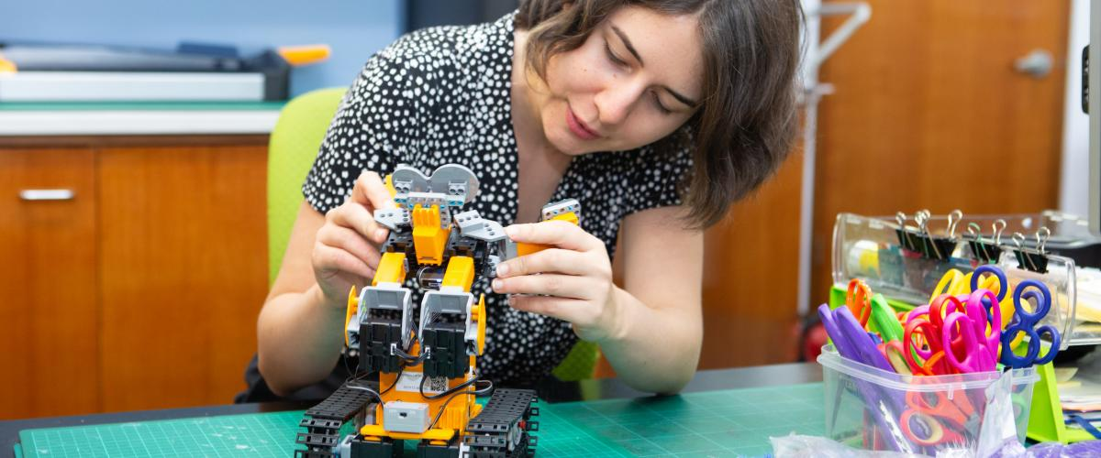~~ ~~HERO-SUBTITLE Access to emerging technology and innovative programs~~

