2021 IKC Workshop
Welcome IKC Coordinators to the State Library Digital Literacy Wiki!
This is a quick thank you from Lyn Thompson, Alan Duncan and James Collins for your session feedback, it was great to meet you and we hope to talk soon.
Below are some links about what was discussed during our session, and if you have any additional questions, send an email to James Collins at james.collins@slq.qld.gov.au or a call at 07 3842 9978
- Digital Literacy Wiki - The home page of this wiki
- Technology Kits - A list of technology kits available to borrow for your IKC
- 360 Video - Resources around creating 360 Video
- Community Scratch Up - Details around the upcoming Community Scratch program
- BeConected Digital Mentor Program - Upskilling library staff, volunteers and interested community members to be local Digital Mentors.
- Digital Health Literacy Program - Empower your community to manage their own digital health future.
- Deadly Digital Communities - Digital skills training program for Aboriginal and Torres Strait Islander people.
~~HERO-IMAGE 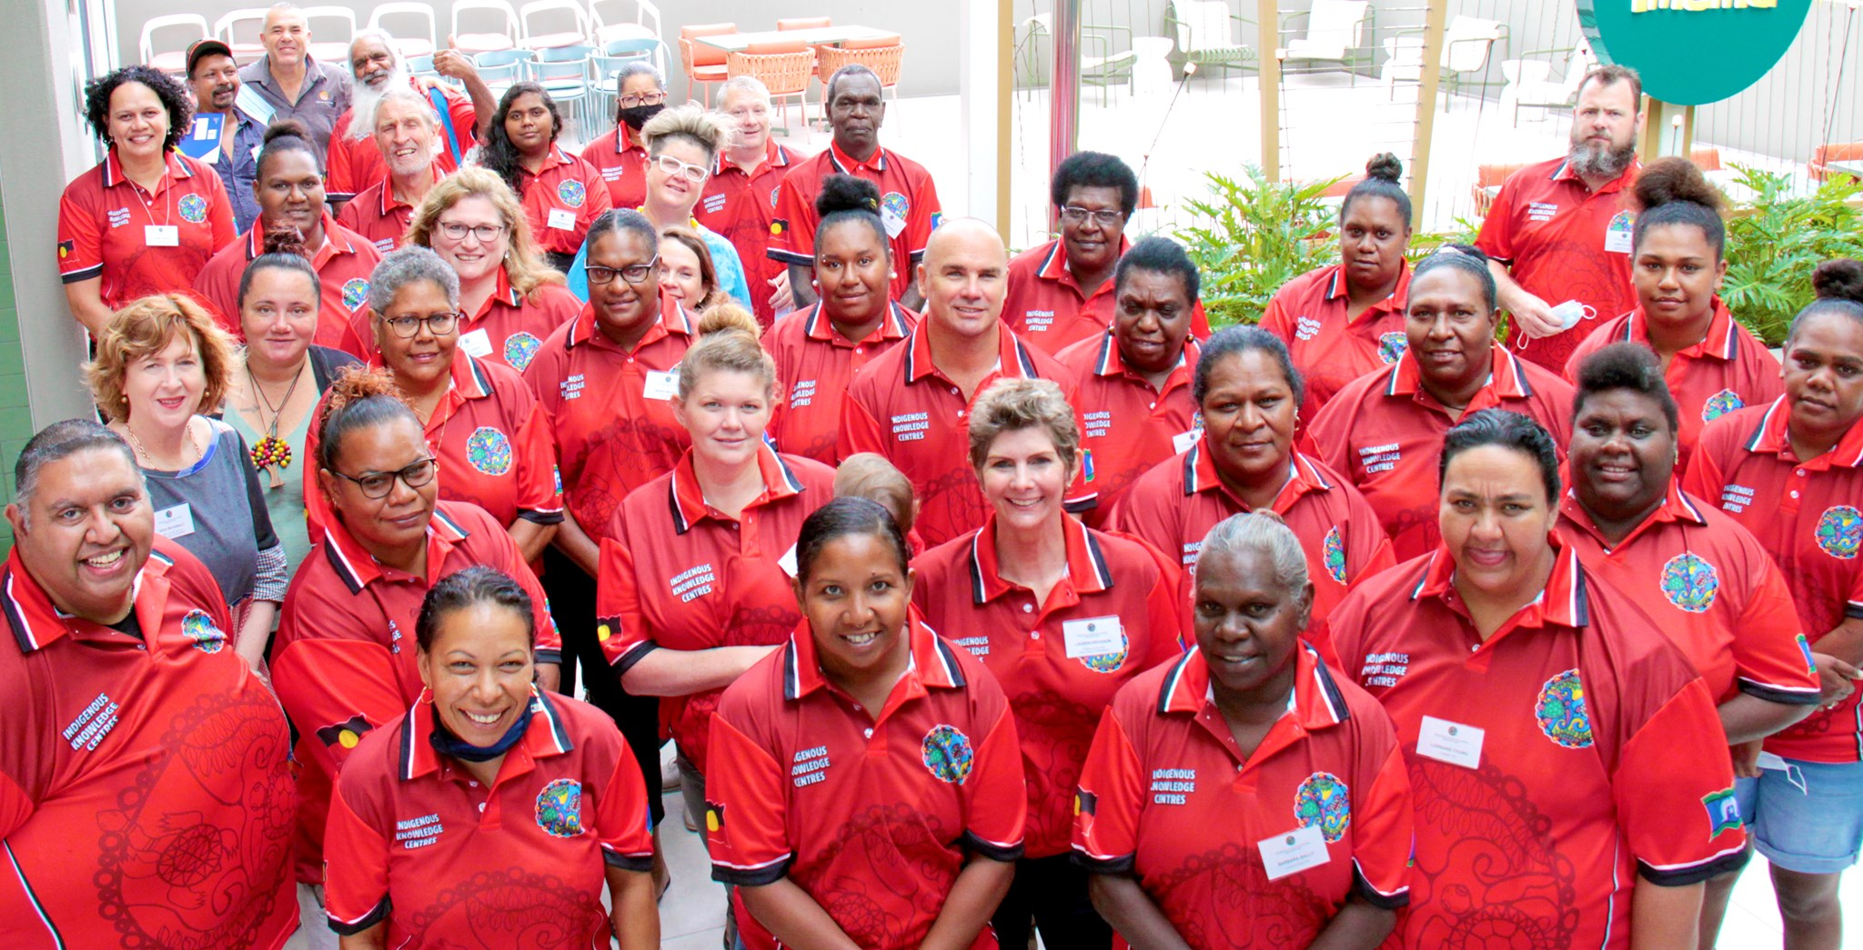~~ ~~HERO-SUBTITLE Learning, Connecting & Collaborating~~

