Live Streaming
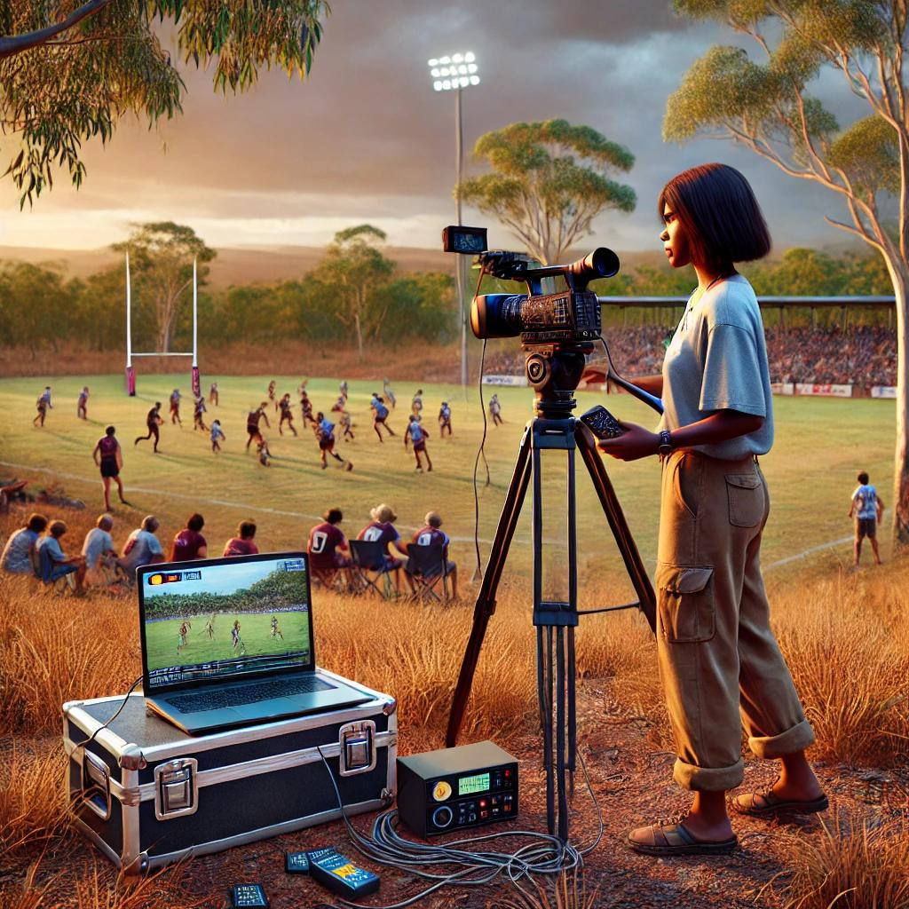
Live Streaming is a workshop designed to ....
Participants will learn the basics of...
The core equipment to run a workshop at your IKC is:
- video camera & tripod
- lighting kit
- Audio (Rode microphone kit)
- Laptop per group with OBS Studio installed
- High speed internet connectivity
- Protecting your personal information online
Open PowerPoint slides

How can I host a Live Streaming workshop?
Talk to James or Dan at State Library of Queensland
daniel.guest@slq.qld.gov.au

