Family History
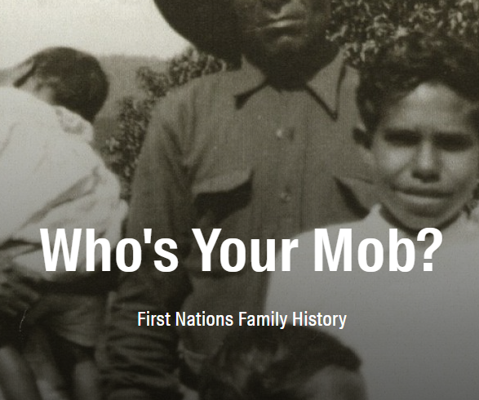
The family history workshop guides participants to trace their family history and access historical records. We focus on the Who's Your Mob resources from the State Library of Queensland and the collections of other record-keeping institutions across Queensland and Australia.
The core equipment to run a workshop at your IKC is:
- Laptop or PC access
- WIFI internet access
- Who's your Mob at the State Library of Queensland
- Family History Guide
- Protecting your personal information online

How can I host a family history workshop?
Talk to James or Dan at State Library of Queensland
daniel.guest@slq.qld.gov.au

