eSports Gaming
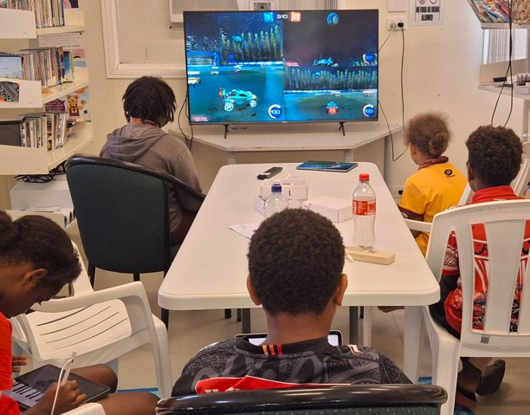
The eSports Gaming workshop guides participants to ...
The core equipment to run a workshop at your IKC is:
- an interactive screen for demonstrations
- Notes and Links Handout
- Protecting your personal information online
Open PowerPoint slides

How can I host a eSports Gaming workshop?
Talk to James or Dan at State Library of Queensland
daniel.guest@slq.qld.gov.au

