Digital Storytelling
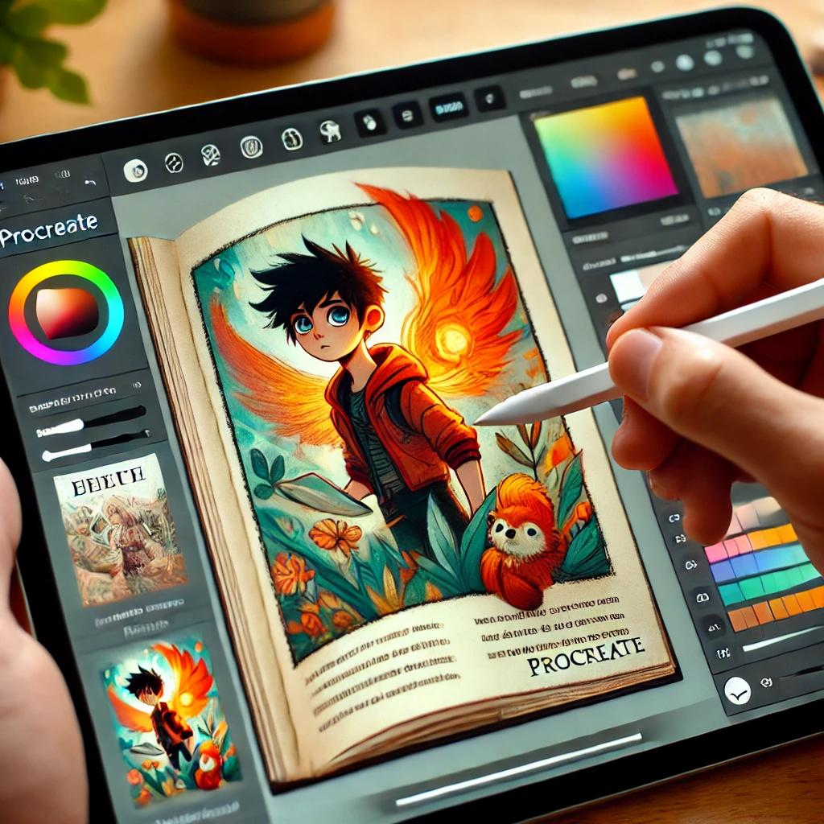
Digital Storytelling is a workshop designed to teach the art of storytelling, digital illustration and eBook creation.
Participants will learn the basics of storytelling structure and explore photography and digital drawing. They will then move on to creating eBook layouts and designs, focusing on integrating text and imagery effectively.
Finally, they will learn how to publish their eBooks online. By the end of the program, participants will have the skills to craft engaging stories, create accompanying visuals, and share their work online with a wider audience.
The core equipment to run a workshop at your IKC is:
- iPad with Book Creator and Procreate apps
- Stylus (optional but recommended)
- Interactive screen for demonstrations
- Blank paper and pencils
- Notes and Links Handout
Protecting your personal information online
Open PowerPoint slides

How can I host a Digital Storytelling workshop?
Talk to James or Dan at State Library of Queensland
daniel.guest@slq.qld.gov.au

