Digital art
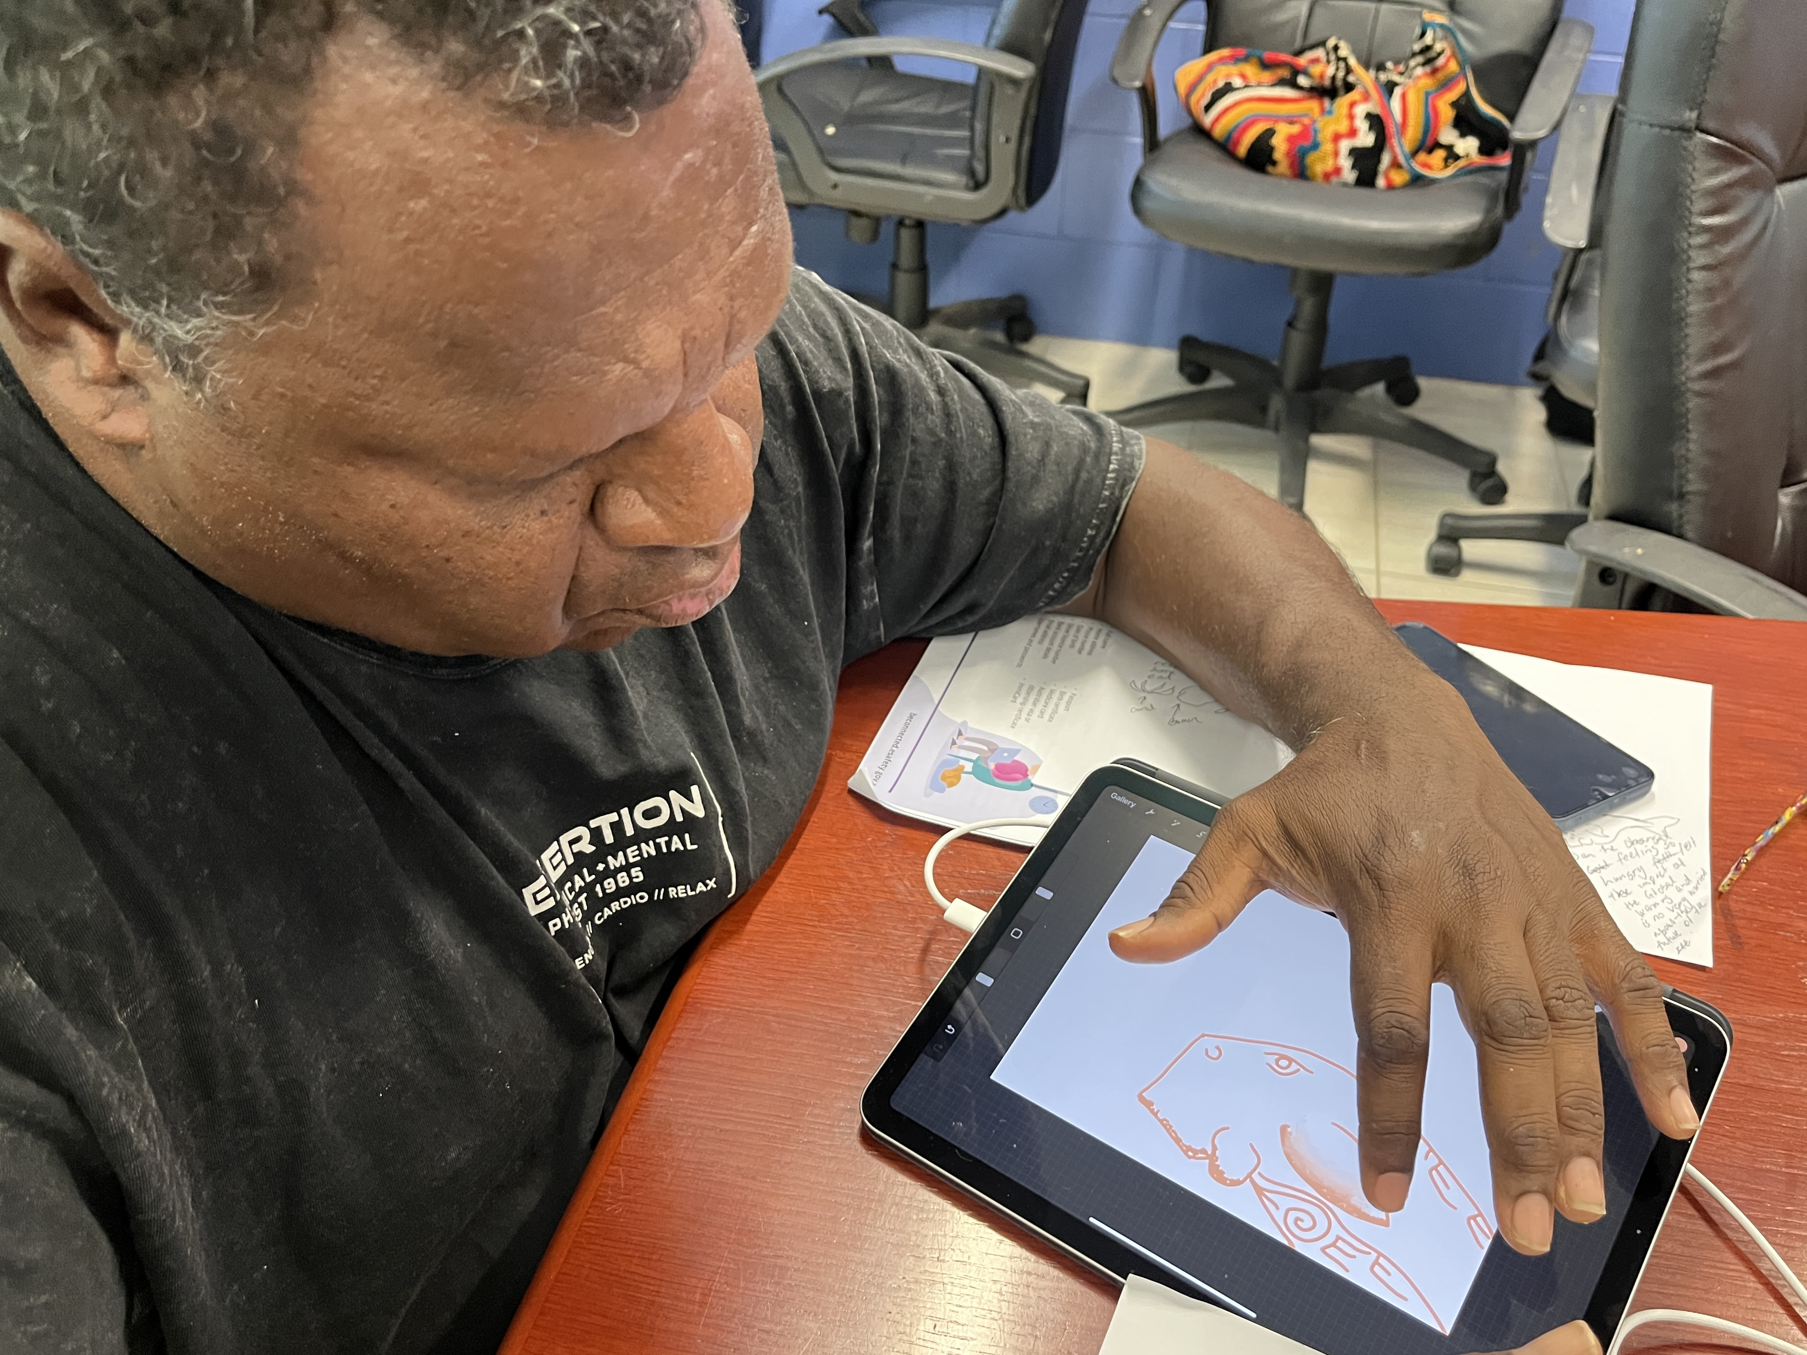
The Digital Art workshop allows participants to create a design on an iPad using the Procreate app, and then transfer that image onto a tshirt using sublimation printing.
The core equipment to run a workshop at your IKC is:
- iPad with the Procreate app installed
- Stylus (optional but recommended)
- Sublimation printer and blank transfer paper
- plain polyester tshirts
- a laptop for printer operation
- Heat press and instructions
- an interactive screen for demonstrations
- Notes and Links Handout
- Protecting your personal information online
Open PowerPoint slides

How can I host a Digital Art workshop?
Talk to James or Dan at State Library of Queensland
daniel.guest@slq.qld.gov.au

